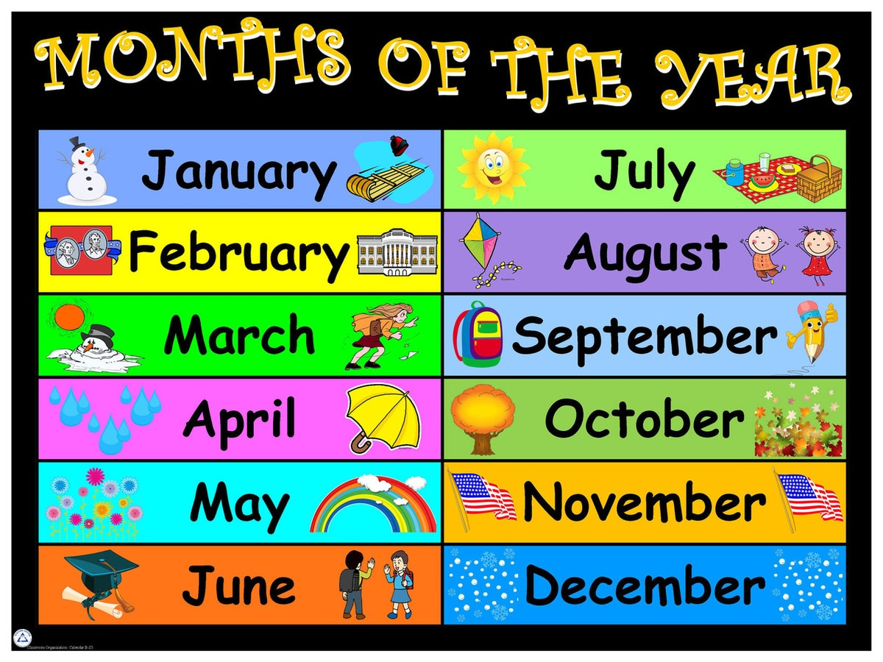

**St. Conleth’s N.S. Newsletter**

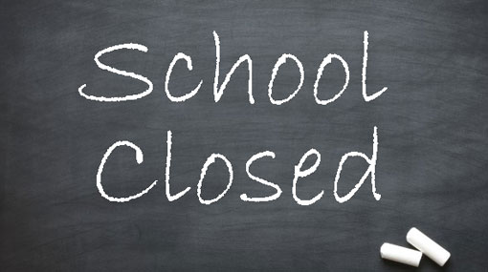

26th October

Contents:

Bring and Buy p. 1

School Self Evaluation p. 1

Mornings at School p. 1

Green Schools News p. 2

Cumann na mBunscol p. 2

Sport Against Racism Ireland p. 3

Demonstration Project p. 3

Erasmus Visitors in November p. 3

Dates to Remember p. 4

Important Masses p. 4

A Thought for November p. 4

Contact Details p. 4

🙞🙜

Bring and Buy

Sixth classes have been really busy, getting ready for the annual Bring and Buy on Thursday 25th. We’re overwhelmed by the generosity of people and cannot believe the incredible donations that have been made. All the children enjoy the Bring and Buy each year. They learn the value of supporting each other. The sellers (and buyers) improve their confidence, improve communication skills and learn about personal responsibility. It is a fun and fruitful day. Thank you for your support.

Mornings at School

Our curriculum is a busy one with a lot for each class to cover in many different subject areas. We ask that you make every effort to have your child in school on time every day.

The bell goes at 9.20am and lessons start promptly. Children who are late miss an important start to the day. If this is a regular occurence, children run the risk of falling behind their classmates. It is vital that children are afforded every opportunity.

Our teachers collect the children from the playground and bring them into the school. All children should walk in with their classmates and teachers. Parents please say your goodbyes in the playground. We ask parents support in encouraging your child’s independence and sense of responsibility.

As the first half term draws to a close, we are confident that all the children are becoming more independent. We thank you for your cooperation in arrival procedures each morning.



School Self Evaluation

Sincere thanks to everybody who completed and returned Science questionnaires. If you have not yet completed the questionnaire, there is still time to do so. We are anxious to hear your views. The questionnaires provide valuable information and direct our future progress, as we formulate our School Improvement Plan. School self-evaluation is a collaborative, inclusive, and reflective process of internal school review. An evidence-based approach, it involves gathering information from a range of sources, and then making judgements. All of this is undertaken with a view to bring about improvements in students’ learning.

 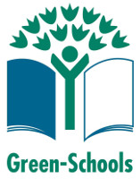

A huge thank you to everyone who sent in clothes for our recent clothes collection. We had 1080 kilogrammes of clothing. The money raised through this collection will be used to fund the cycle training for sixth class this year. The cycle training teaches valuable skills that are necessary to keep safe when cycling. We had Goshka from Heritage in Schools visiting us on Thursday 4th October. Ms. O’ Brien’s class and Mrs. Cooney’s class learned all about biodiversity and had some interesting and fun lessons down in the Community Garden. We also had a Science workshop on October 17th to mark Climate Action Week. Ms. Jameson’s learned a lot on the day about molecules and atoms, ourselves and our DNA, pollution and the environment. Climate Change is central to every Green-Schools theme and present in nearly every aspect of our S.E.S.E. curriculum, as well as being vitally important in all of our futures. Thanks to you the parents for your support with our clothing collection and to all the children that work so hard to keep us Green.

Green Schools News

Cumann na mBunscol In early September Mrs. Colleary gathered together 19 under 11 boys to prepare for the opening round of the under 11 league. For our first game Ardclough travelled to Carbury on a wet, windy afternoon. The boys showed great teamwork and determination and pulled though in the last few minutes with a one goal victory on a score-line of 4:4 to 3:4. In our second game we travelled to Robertstown in lovely bright conditions. The boys had a very convincing win that day winning by 11:5 to 3:2. With most of the team getting their names on the scoreboard that day, it truly was a great team effort. Our last game in the preliminary round saw Straffan travel to Carbury. In a hard-fought game, with all the boys defending really well, we came away with a victory which saw us straight through to the semi-final. With confidence high and the team emerging as a force to be reckoned with, we prepared to take on Athgarvan the following week. On a very bright, but windy day, we travelled to Robertstown, to play the semi-final. The boys had to fight to the bitter end to come away with a win and their place in the under 11 final. The match finished with Derrinturn 1:5 to Athgarvan’s 4 points. All the children and staff got behind the team in preparation for the final and there was a wonderful atmosphere of camaraderie in the school as flags and posters were created and displayed prominently to support the boys and their fantastic coach, Mrs. Colleary. The boys were cheered onto the bus on Wednesday 17th October by the whole school. The boys got off to a fantastic start and gave a magnificent display of football, putting pressure on a strong Nurney side. The boys were winning by seven points at half time. The performance remained strong in the second half as the boys did their very best. Unfortunately we were beaten, despite being the better team throughout. The boys were gracious in defeat and respectful of their rivals. Boys, you are the real winners in our eyes. Congratulations to Mrs. Colleary, Mrs. Kenny, Audrey, Margaret and Kelly (the backroom team) and Carbury GAA for letting us use the pitch and providing refreshments on arrival back form the final. We are very grateful to you all. Special thanks to each and every one of the boys: Luke Stack, Josh O’ Hanlon Canning, Jamie O’ Connor, Tom Norton, Evan Moore, Tony McCann, Conor Martin, Daniel Kelly, Paul Kavanagh, Tyler James, Callum Healy, Jack Fox, Shaun Fox, Sean Fennessy, Jamie Carberry, Jack Byrne, Adam Brennan, Evan Boyle and Rhys Bannon.

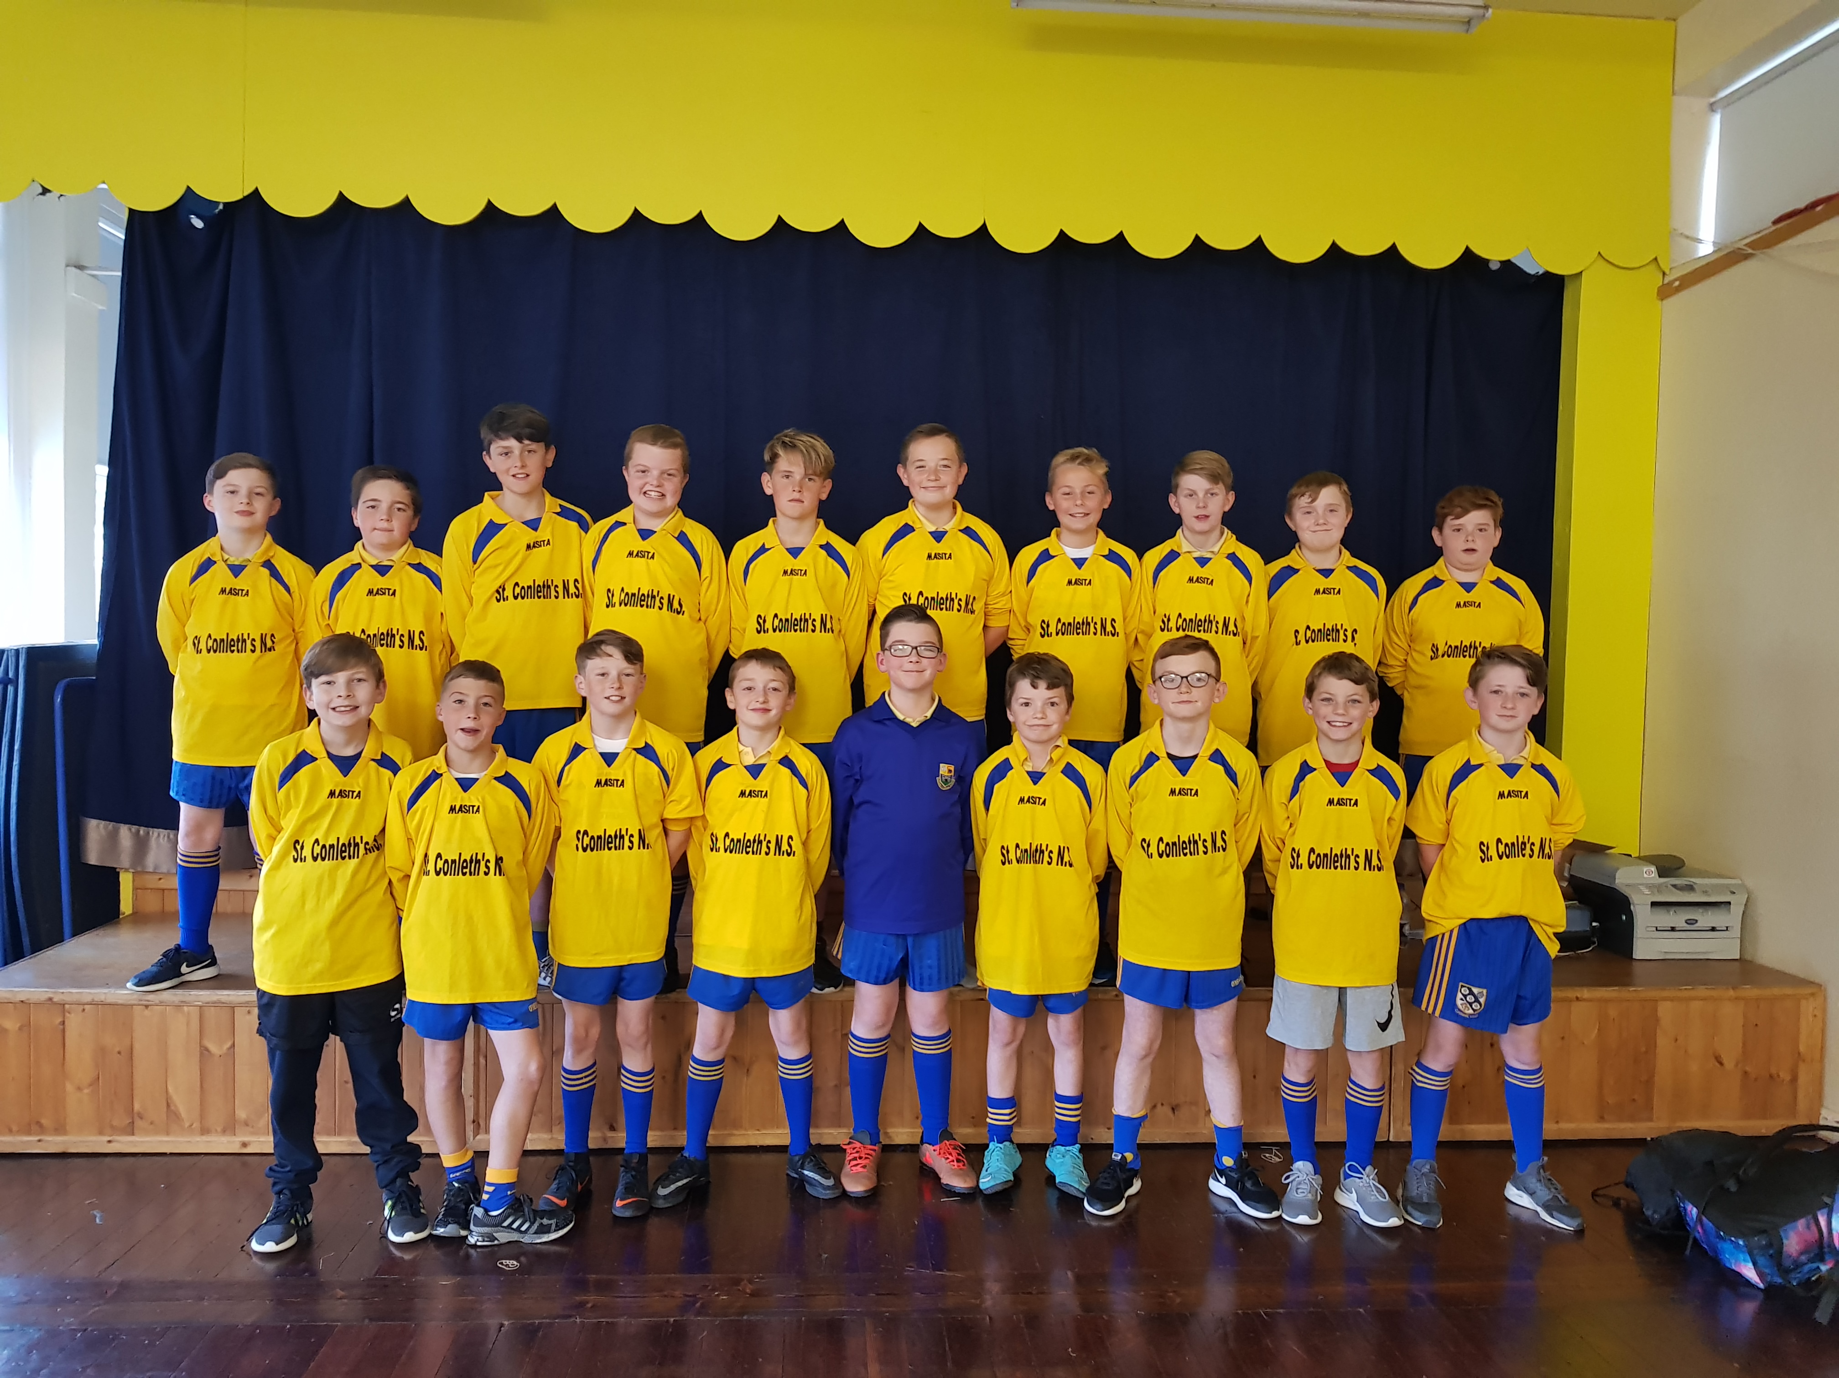

Sport Against Racism Ireland

Sport Against Racism Ireland recently sucured funding from the Department of Justice to travel around the country during October, November and December 2018, delivering free anti-discrimination soccer workshop to schools and youth groups. Addressing racism and other forms of discrimination, the workshops are led by SARI youth coaches from ethnic minority backgrounds. The workshops comprise soccer training games and exercises with built in awareness of what it means to discriminate on and off the pitch.

We were lucky enough to be able to participate in this training. We thank Mrs. Kenny for following up on this training opportunity. It was informative, enlightening and absolutely brilliant fun. The children enjoyed every minute.

The visiting SARI coaches commented on the wonderful students in the school, mentioning their attention, respect and willingness to learn. SARI encourages positive integration and social inclusion through sport and the children of our school lived up to the guiding principles of inclusion and fair play.

Why not visit the Sport Against Racism Ireland website at [www.sari.ie](http://www.sari.ie) to see some of the wonderful activities that are going on.

Demonstration Project

Our school is taking part in the Demonstration Project on In-school and Early Years Therapy Support. This is a joint project by the Department of Education and Skills, the Department of Health and the Department of Children and Youth Affairs. The project involves school staff, Speech and Language Therapists, Occupational Therapists and families working together to support the learning of all students. The project will be managed by the National Council for Special Education. The therapists in the project will not replace existing HSE or HSE funded services. This means that if your child is currently attending/on a waiting list for a HSE therapist, this will not change. The project is part of the government’s overall plan to provide more support to help every child to learn and participate in school to the best of his/her ability. The therapists will work with school staff to support students across the whole school and to provide support to students in classrooms, in small groups and/or individually. If your child is identified as needing additional support for Speech and Language or Occupational therapies, you will be informed by the teacher and together a plan will be put in place. If the therapists and the teacher need to work together with your child in a group to help their learning needs, you will be asked for written consent. You will also be asked for written consent if your child is offered individualised support.

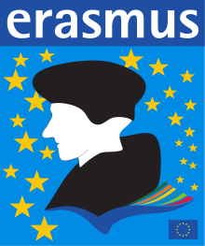

Erasmus Visitors in November

Erasmus+ is the EU's programme to support education, training, youth and sport in Europe.

Our school is involved in an Erasmus+ 'Strategic Partnership'. Strategic Partnerships are transnational projects designed to develop and share innovative practices and promote cooperation, peer learning, and exchanges of experiences. Our six partner schools are situated in Finland, Spain, Italy and Northern Ireland. On November 7th, teachers from these schools will visit St. Conleth’s. They will share their teaching and learning experiences and learn from what they see in our school. Our project is called Da Vinci 2019. Da. Vinci dreamed that he would fly and we want our pupils in the six schools to fly above the rest in the fields of science, technology, engineering, the arts and maths. We believe that the link between science and the arts is embodied in the work of Leonardo Da Vinci. The theme of Da Vinci is an attempt to link creativity to better science teaching and learning. The schools wish to share ideas about science teaching as well as including the arts in our curriculum. We see the value in developing the creative skills necessary for an enterprise culture in all pupils, including those with different talents and needs.



Halloween Break - Closing October 25th

Presidential Election (School Closed) October 26th

Re-opening November 5th

Erasmus Visitors November 7th

Confirmation February 27th

First Confession March 7th

First Holy Communion May 25th

**Important Masses**

**CONFIRMATION CLASSES**

18th November 2018 Enrolment Ceremony (11am)

17th February 2019 Ceremony of Light (11am)

27th February 2019 Confirmation Ceremony (2pm)

You Shall be my Witness Programme

*Week 1 - January 7th in Derrinturn School at 7:30pm*

*Week 2 – January 14th in Derrinturn School at 7:30pm*

*Week 3 – January 21st in Derrinturn School at 7:30pm*

*Week 4 – January 28th in Derrinturn School at 7:30pm*

**Important Masses**

**COMMUNION CLASSES**

28th October 2018 30th Sunday in Ordinary Time.

25th November 2018 Feast of Christ King.

*16th*  December 2018 3rd Sunday of Advent.

27th January 2019 3rd Sunday in Ordinary Time.

17th March 2019 3rd Sunday in Lent.

14th April 2019 Palm Sunday.

5th May 2019 3rd Sunday of Easter.

18 June 2019 Feast of Corpus Christi.

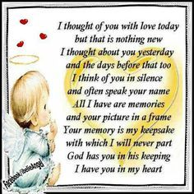

**A Thought**

**for November**

**– the Month**

**of the**

**Holy Souls**

Keeping in Touch

Please inform the school if you have changed your address or telephone numbers. We may need to contact you or send school texts.

CONTACT DETAILS

St. Conleth’s National School, Derrinturn, Carbury, Co. Kildare.

Tel: 046 9553490

E-mail: [secretary@stconlethsns.ie](mailto:secretary@stconlethsns.ie)

Website: [www.stconlethsns.weebly.com](http://www.stconlethsns.weebly.com)



**www.stconlethsns.weebly.com**