

CONTENTS

Page 1: Parent Teacher Meetings

Demonstration Project

Page 2: Carol Service

Bring & Buy

Page 3: Green Schools Bottle Bank

Digital Delights

Christmas Jumpers

Page 4: Charity at Christmas

Primary Language Curriculum

Important Dates CONTACT DETAILS St. Conleth’s National School, Derrinturn, Carbury, Co. Kildare. Tel: 046 9553490 E-mail: [secretary@stconlethsns.ie](mailto:secretary@stconlethsns.ie) Website: [www.stconlethsns.weebly.com](http://www.stconlethsns.weebly.com)

**St. Conleth’s N. S.**

**November 2019**

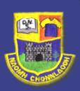

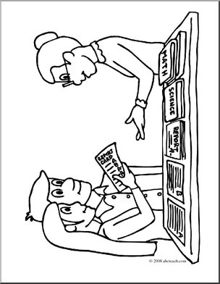

PARENT TEACHER MEETINGS

We take this opportunity to thank all the parents and guardians for attending the Parent-Teacher meetings this month. Good collaboration between school and home is a significant factor in the successes and levels of attainment of our children. Your support and encouragement are truly appreciated. If you were unable to attend the meeting please see our guidelines on communication. This is available on the school website, https://stconlethsns.weebly.com. Please ring to make an appointment if you wish to meet a member of staff. Teachers cannot accommodate meetings during class unless supervision for the class has been arranged.

Demonstration Project on In-School and Early Years Therapy.

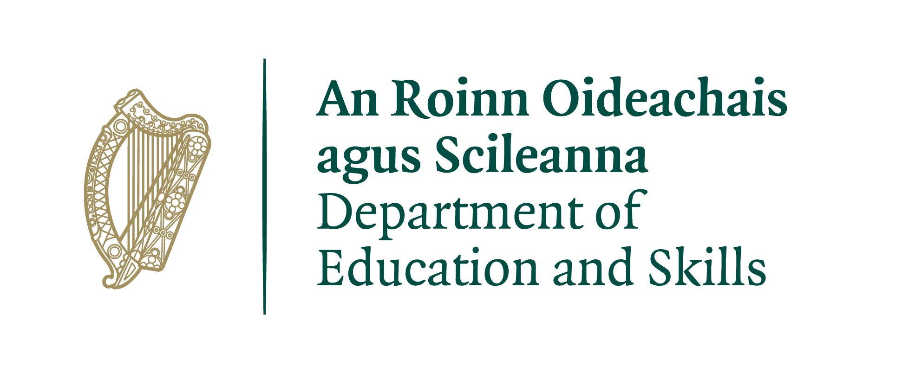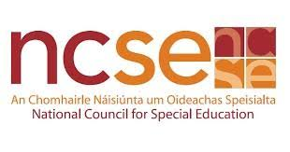

The school is currently in the second year of a demonstration project on In-School and Early Years Therapy, involving occupational therapists and speech and language therapists. Only seventy-five schools are involved and two schools in the parish have been selected to participate. The project is managed by the National Council for Special Education. The therapists in the project will not replace existing HSE or HSE funded SLT and OT services. This means that if your child is currently attending/on a waiting list for a HSE SLT or OT, this will not change. The project is part of the government’s overall plan to provide more support to help every child to learn and participate in school to the best of their ability. Information about the project is available on the school website, <https://stconlethsns.weebly.com>. Information leaflets are also available at the office. Please feel free to request a copy.

Carol Service

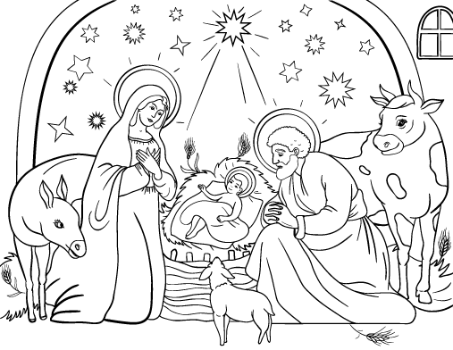

**SCHEDULE FOR CAROL SERVICES**

Our Carol Service returns this year in response to great demand. The Carol Services will take place on Tuesday 3rd and Wednesday 4th of December in Holy Trinity Church. Tickets are available from the school office. Tickets are limited initially to two per family as the seating is limited. It is a small setting, but this allows for a beautiful personal and exclusive performance. We look forward to seeing you at our concert. The children are very excited about performing for you. We thank them for their hard work. Thanks also to the teachers for preparing and rehearsing. Thanks to Carol for running the box office. Special thanks to Mrs. O’ Donoghue, who has scripted the show and is the mastermind behind the evenings.

|  |  |
| --- | --- |
| Tuesday 3rd December | Wednesday 4th December |
| Junior Infants – Mrs. Byrne  Síoga – Ms. Healy  1st & 2nd – Mr. Dunne  3rd – Mrs. Cooney  3rd & 4th – Ms. Howe  5th Class –Mr. Hughes  5th & 6th – Ms. O’ Neill | Junior & Senior Infants – Ms. Rowe  Senior Infnats – Mrs. Grogan  1st - Mr. Farrell  2nd – Ms. O’ Brien  4th – Mr. Freeman  6th – Mrs. O’ Donoghue |

Bring and Buy

On October 5th the pupils of 6th class held the Annual Bring and Buy. Mrs. O’ Donoghue, Ms. O’ Neill and the children had spent weeks preparing for the big day. Along with the sale of items were competitions to guess the number of sweets in the jar and to guess a doll’s name. This event has always been a highlight of the year for sixth class and the children said that they have always wanted to run the sale. They could not believe that they have finally reached sixth class and are in charge of the operation. They have really excelled as entrepreneurs, organisers, advertisers and salespeople. Huge thanks to Mrs. O’ Donoghue, Ms. O’ Neill and their team in 6th class. Well done to you all and thanks to all the parents and families that contributed to the fun-filled fund-raiser. A whopping €1385.00 was raised on the day.

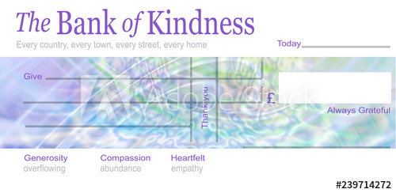

*25/10/2019*

**St. Conleth’s National School**

**One thousand, three hundred &**

**eighty-five euro only**

eigh

€

*1385.00*

Green Schools Bottle Bank!

*A million plastic bottles are bought around the world every minute and the number will jump another 20% by 2021, creating an environmental crisis some campaigners predict will be as serious as climate change.* Our Green School activists are very concerned about the statistics. Staff have discussed the problem and Ms. Keown suggested that the Green School Committee would organise collection of the bottles for a week so that the enormity of the problem could be seen in all its plastic glory! So we gathered the empty bottles from school lunches for one week. Mr. Farrell kindly offered to store our bottles in his room and all the teachers collected the bottles and sent them to his room. We were shocked at the size of the bottle bank at the end of the week. The huge collection of almost 900 bottles was moved to the hall for assembly so that all the children could see the magnitude of the problem. A lot of man-power and child-power was required to shift all the bottles!

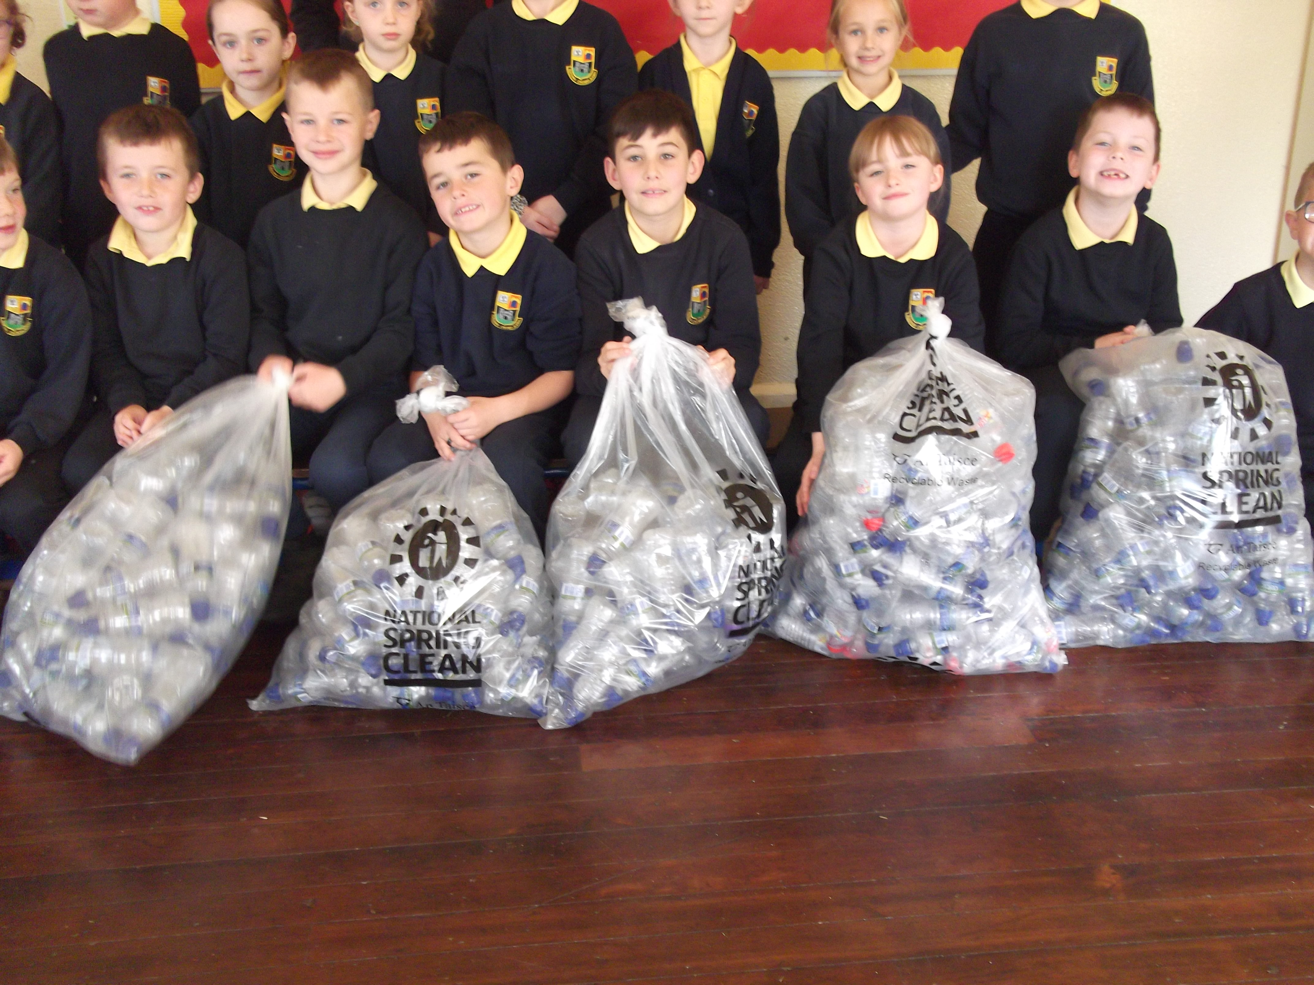 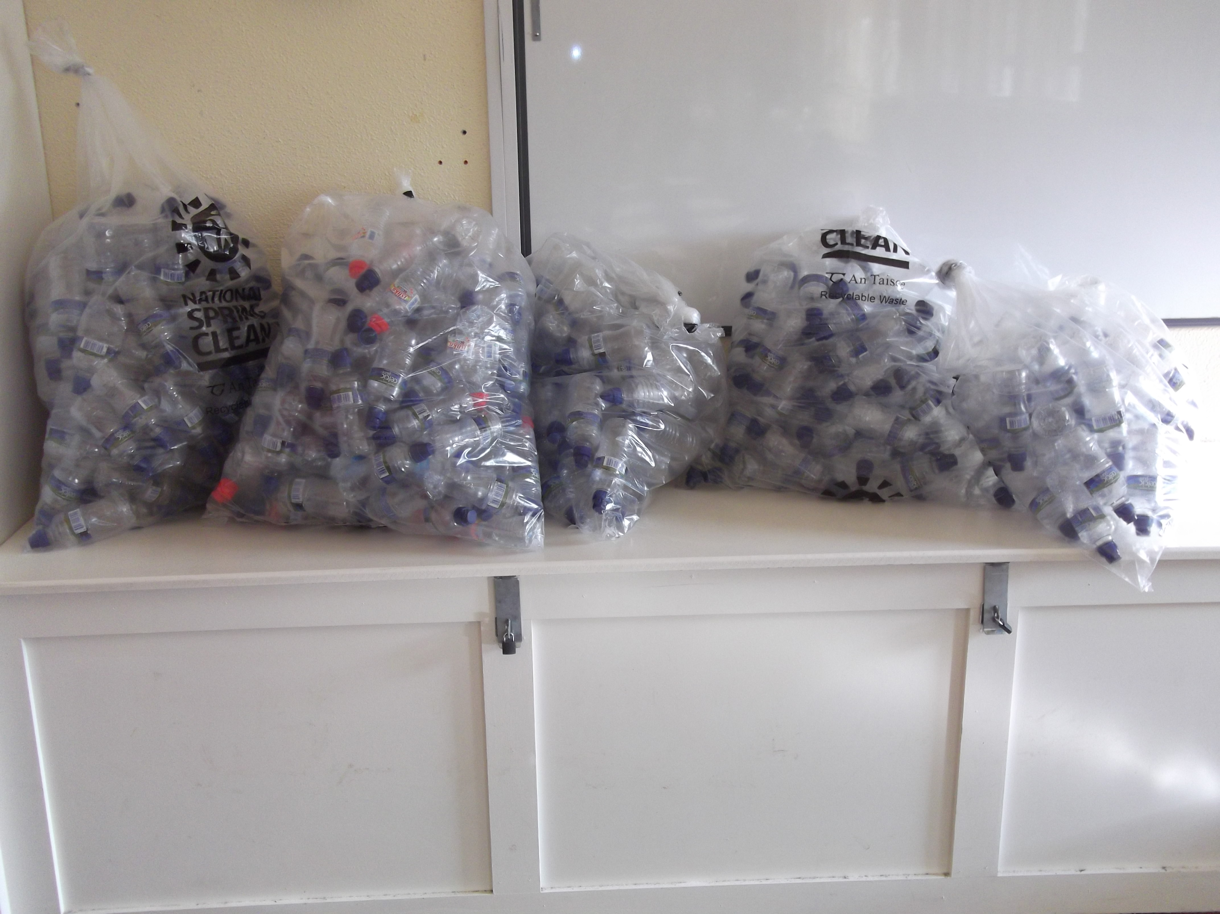

Ms. Keown and Mrs. Kirk asked the children to consider the problem and think about solutions. The Parents Association had sought solutions to this problem last year. It became difficult to find a solution as our lunch scheme had to provide a drink as one of the options. Everyone in school was concerned about this. Lots of wonderful ideas were suggested, but each potential solution seemed to present another problem or challenge. Ms. Rowe realised that everyone’s best efforts were being hampered by the constrictions of the lunch cub guidelines. So she decided to question politicians and government departments and although the road was windy and required revisiting people and places several times, Ms. Rowe did not give up. Thanks to her efforts and determination, we have been given permission by the department that funds our school lunch scheme, to replace the water bottles with a small food item. From January onwards, children will be able to bring a drink in a reusable bottle. The lunch club option sheets will reflect this. This will reduce waste, save on refuse collection and reduce the schools’ carbon footprint. The whole school has been involved in this activity and we are delighted to have made progress.

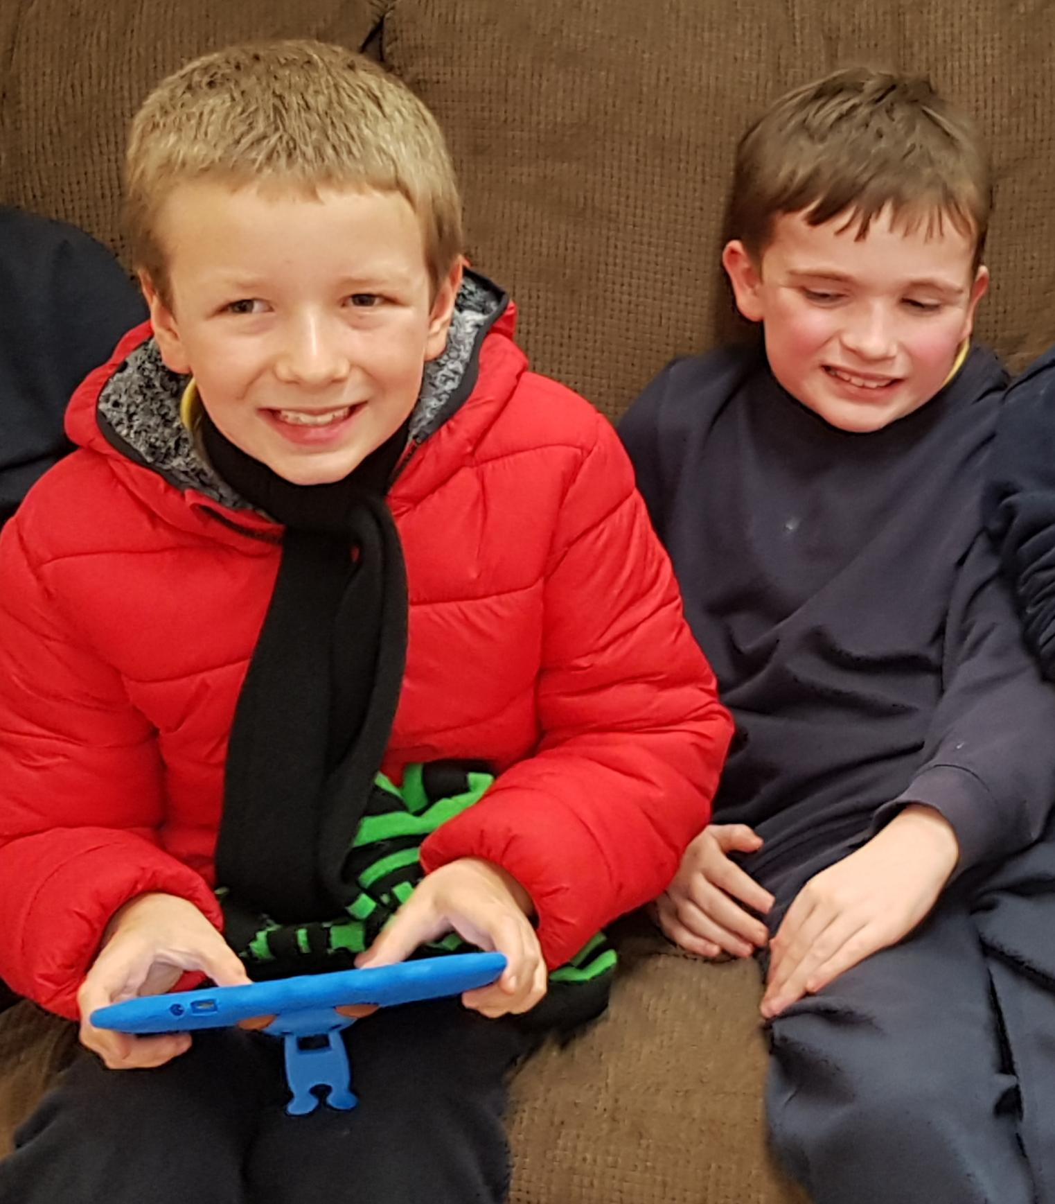 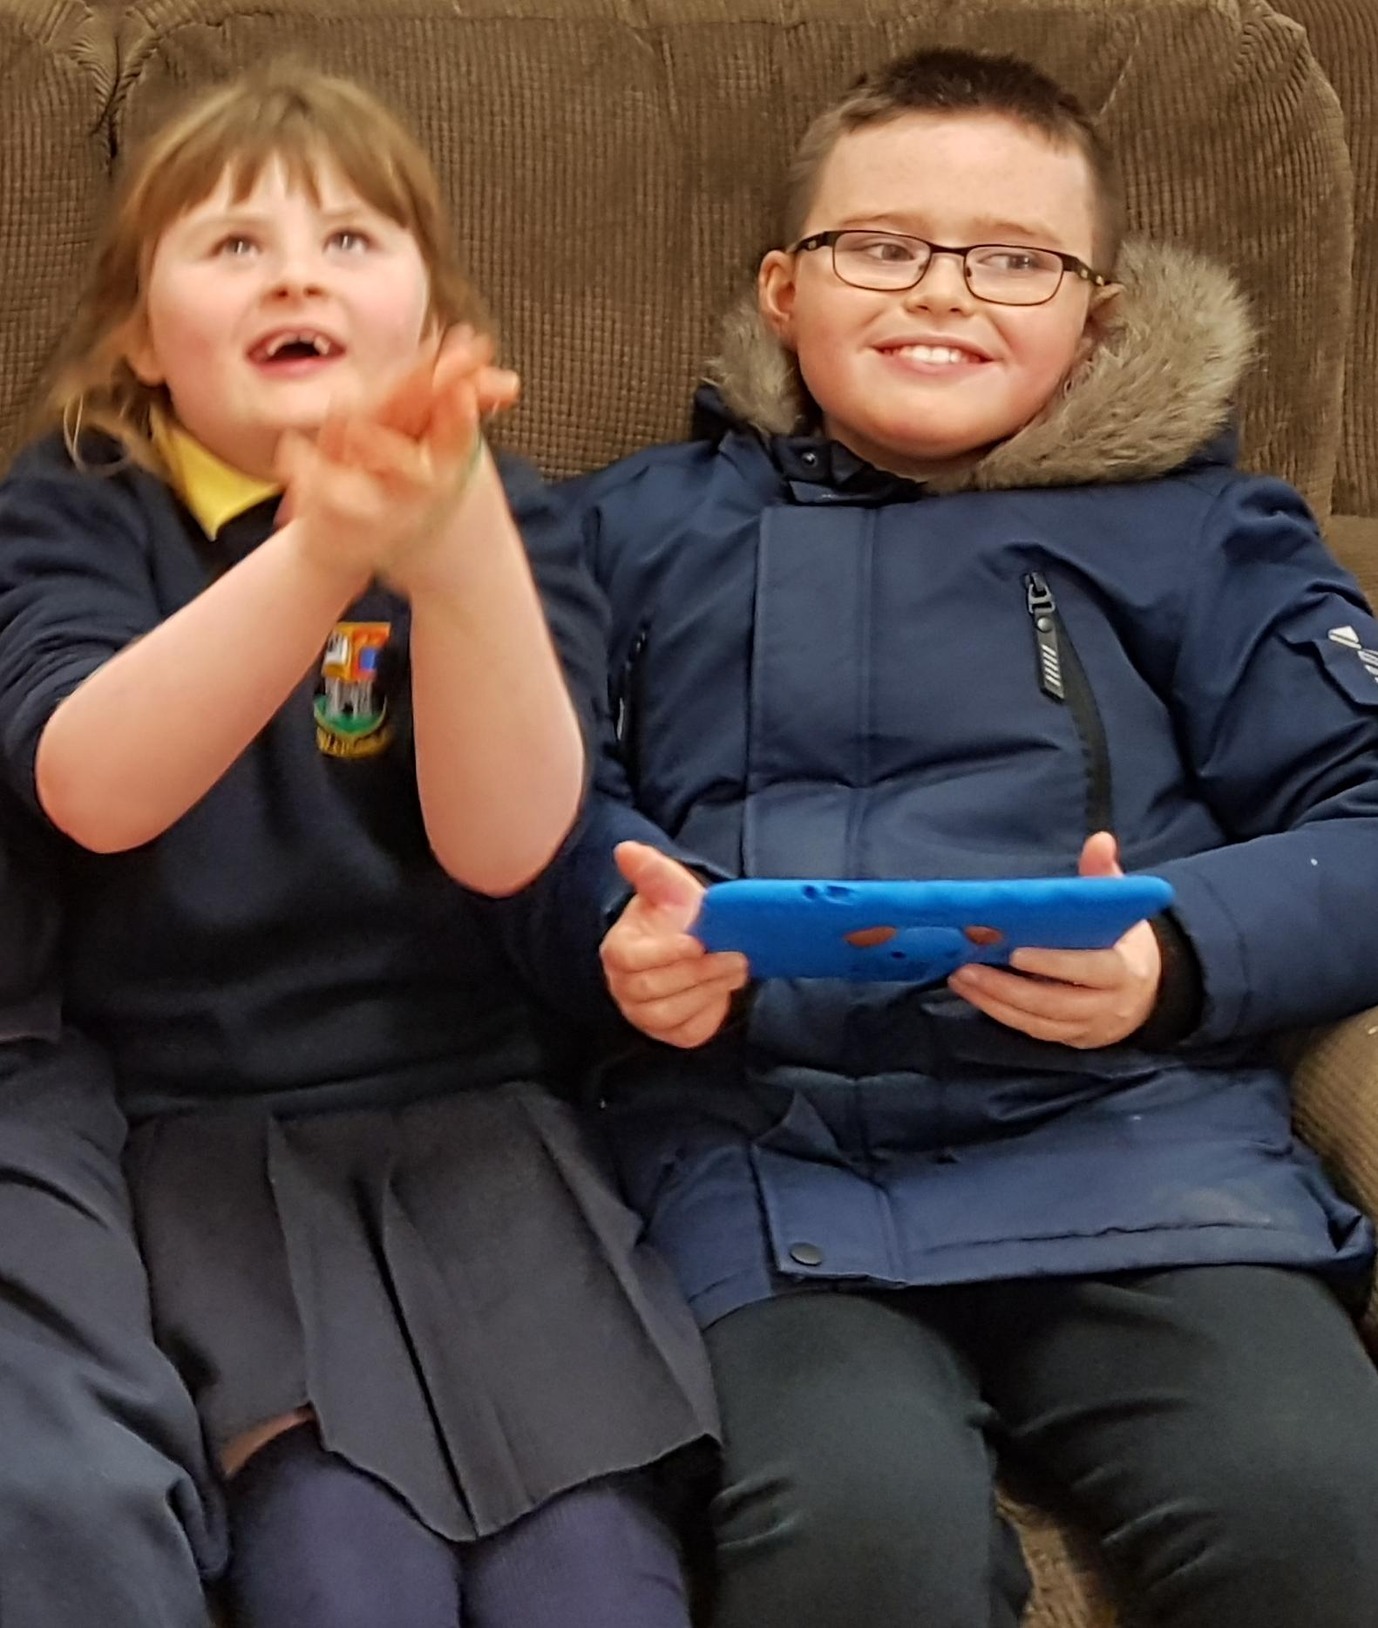

Digital delights!

Our Síoga class have just received tablets, which were funded by the generous donation of Coill Dubh A.F.C. last month. Thanks again to those involved. The children and staff are delighted with the new tablets. Thank you!

Christmas Jumpers

The children in 6th class are grateful to those who helped raise money at the Bring and Buy. Now they hope to extend their generosity to others. Christmas Jumper Day is a great way to support sick children in Crumlin hospital. Over 150,000 children go through the doors of CHI Crumlin every year. CMRF has helped families in most communities across Ireland. Childhood illness takes too many precious moments of laughter, play and happiness. Christmas should be a special time for them no matter where they are. Our senior classes are celebrating a Christmas Jumper Day on Friday December 13th so that they can contribute to Crumlin’s appeal and create some magical memories for sick children this Christmas.

Christmas Charity

We feel it is important that children develop the spirit of giving, a sense of empathy with those in need and an understanding of disadvantage in our society. During the season of giving and receiving, we always collect for charity. This year we are collecting donations for winter kits for homeless people in Kildare. We want to involve the children and their families in collecting winter clothing, toiletries and hygiene products. A list of suggested items is printed in the box below. The items will be collected from the school by Elaine Hickey, packaged and distributed to the homeless for Christmas. It is important that the children learn to give and understand charitable works. We thank you for your cooperation and generosity.

Suggested items to donate:-

Toothbrush & toothpaste Mouthwash (alcohol free) Dental floss

Tissues Wet wipes Plasters

Shampoo (travel size) Shower gel (travel size) Soap

Deodorant (Roll-on) Disposable razors Lip balm

Comb Ladies sanitary products Hairbrush

Socks Gloves Hats

Scarves Cereal bars Sweets

Chocolate

Primary Language Curriculum

The new Primary Language Curriculum is now being introduced for classes from third to sixth. The teaching staff have had an in-service training day in October and later in the year there will be a half-day closure to facilitate further training. The curriculum is rolling out over a three-year period. From time to time, articles about the new curriculum will be published in this newsletter and on our website <https://stconlethsns.weebly.com>. In the meantime, you may like to visit this link: <https://www.ncca.ie/en/resources/primary-language-curriculum-information-leaflet-for-parents-en> for more information on what lies ahead.

Sunday 1st December Confirmation Enrolment Ceremony

Tuesday 3rd December Santa & his Fairy-tale Friends

Tuesday 3rd December Carol Service

Wednesday 4th December Carol Service

9th & 10th December Children’s School Lives Research

Friday 13th December Parents Association Raffle

Christmas jumper Day in 6th

Friday 20th December Closing for Christmas Holidays

Monday 6th January 2020 Re-opening after holidays

