

**St. Conleth’s N.S. Newsletter**

CONTENTS

   

**Page 4**

Seachtain na Gaeilge Dates of Note Contact Details

**Page 2**

Confirmation First Confession Lent

**Page 3**

Green Schools News Sports Update

**Page 1**

Fundraiser on World Autism Day Stay Safe Lessons



Next Tuesday, April 2nd, marks the 12th Annual World Autism Awareness Day.

We would like to join the international community in their recognition for people with autism by wearing blue on the day. We kindly ask for a donation for this non-uniform day to support our special classes for children with autism - *Síoga* and *Síolta.*

Specialised equipment and resources can be expensive so both classes have a wish list of items that they would benefit from. Such items include a Pics for PECS cd which is programme to help children communicate using pictures, sensory toys, board games and bikes for the older children in Síolta.

Any donation, no matter how big or small would be greatly appreciated. We look forward to celebrating this special day by wearing blue and continuing to create an awareness for people with autism.

Stay Safe Lessons Currently, all our classes are covering Stay Safe lessons. The Stay Safe programme is part of the Social, Personal and Health Education curriculum. The aim of the Stay Safe programme is to teach children personal safety skills so they can look after themselves in situations, which could be upsetting or dangerous. It deals initially with common situations, which most children will experience at some stage or other, e.g. getting lost or being bullied. The programme also teaches children the safety skills necessary to protect themselves from abuse and emphasises the importance of telling a trusted adult about any problems they have. Co-operation between parents and teachers is essential to the success of this programme. It is important that parents are aware of the content of the Stay Safe lessons and are able to discuss the lessons with their children. Your child may bring home worksheets, which will inform you on the topics being covered in class and how you can reinforce the messages at home. Teachers and parents work together to ensure that children learn the skills they need to keep safe. The website [www.staysafe.ie](http://www.staysafe.ie) has a parents section with lots of information. Thank you for supporting this very important part of the school curriculum.

**Confirmation.**

Congratulations to all the children in sixth class who made their confirmation on Wednesday, February 27th. This was a very special ceremony as they entered into a new phase of development as Christians and as teenagers. The Bishop was very impressed with the children and commented on the support received from parents, teachers and the parish community. We hope that the children and their families enjoyed the Confirmation celebrations. *“May the Holy Spirit guide you through life and may He inform and inspire your choices.”*

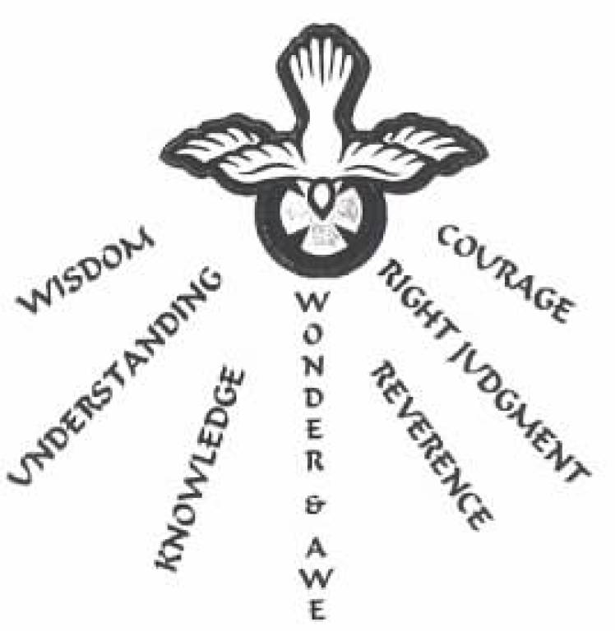

**First Confession.**

Children from second classes made their First Confession on March 7th. It was a beautiful evening and the children were very sincere and penitent. The teachers, Ms. Gleeson and Ms. Healy did an amazing job preparing the children for this beautiful ceremony. The Parents Association organised a lovely reception for all at the school after the ceremony. Thanks to everyone for this amazing evening

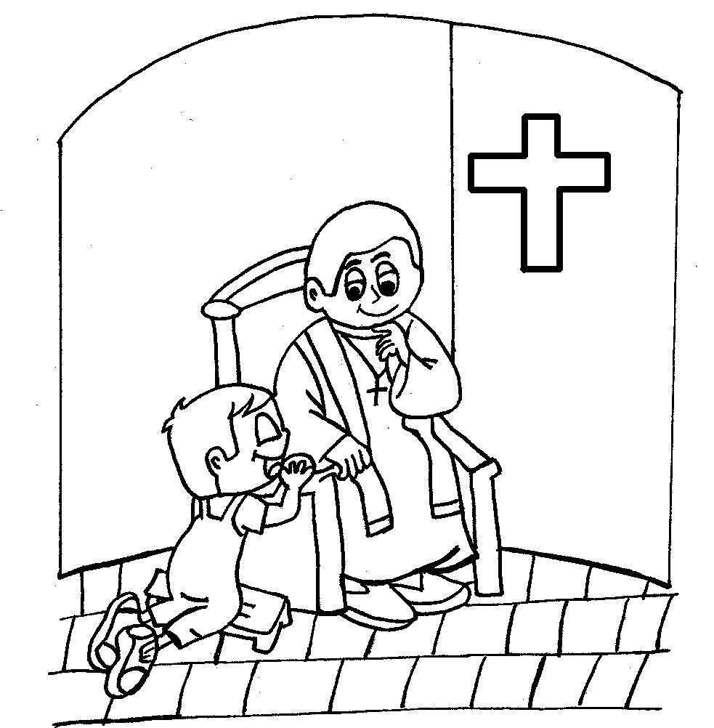 

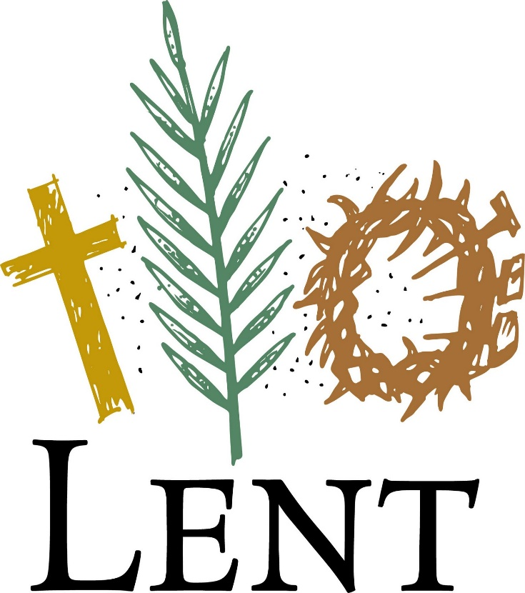

Lent culminates in Holy Week. Holy Week begins with Palm Sunday, a day which commemorates Jesus’ triumphant procession into Jerusalem on a donkey. In the churches the congregation are given palm branches.The priest blesses the palm during Mass.

The Thursday before Easter is Holy Thursday. It is a reminder of the last meal Jesus ate with his disciples, washing their feet and leading them in the first ever Eucharist. He foretold his death, using the symbols of bread for his body, and wine for his blood. The following day is Good Friday, a day commemorating Jesus’ death on the cross. It is a day of mourning, when we remember the suffering and pain of Christ. Good Friday is so called because the death of Christ, as terrible as it was, led to the resurrection, which brought new life to us -the nature of Jesus’ sacrifice overcomes the weakness of humanity.

On Easter Sunday, the Church celebrates Jesus' resurrection. The priest will light a paschal candle to represent the eternal presence of Jesus, as he rises from the dead. The story of Lent is one of sadness and joy; a story which is still celebrated in diverse ways throughout the world today.

**We wish you all a happy Easter. Beannachtaí na Cásca oraaibh go léir.**

What is Lent? For some, Lent is a time for giving up chocolate or something else after Pancake Tuesday. The arrival of Lent is characterised by pancakes! Shrove Tuesday, a day highly anticipated by all pancake lovers, is traditionally a day of preparation before the season of Lent begins. The 40 days of Lent represent the [40 days that Jesus spent in the wilderness](https://www.biblegateway.com/passage/?search=Luke%204%3A1-13) at the start of his ministry. Jesus fasted during his time in the wilderness, and so Christians identify with his suffering by giving things up for Lent.

Shrove Tuesday gets its name from the ritual of ‘shriving’. This 1,000 year old practice involves a person confessing their mistakes, and receiving absolution for them before Lent begins.

Lent begins on Ash Wednesday, a day of penitence or cleansing of the soul. People are marked with a cross of ashes on their forehead. This is a sign of mortality, based upon the idea from the book of Genesis that humankind came into the world from dust and will return to it. It is a time to express sorrow over sin, and a reminder that Jesus brings freedom from sin.

**Green Schools News**

**Heritage in Schools** On Monday 25th March, we had a visit from a Heritage in Schools specialist Mairead Stack. Children from Mr Farrell’s and Ms Gleeson’s class had a very enjoyable morning learning how to become wildlife detectives. They put their wildlife detection skills to practise outside in our school yard and our school field and found evidence of loads of animals living around us, such as badgers and foxes. In the afternoon Mr Dunne’s class learned about wildlife and habitats around Derrinturn, focussing on raised bog habitats and wildlife. They also went outside to check for all the flora and fauna in the school grounds. It was a very enjoyable experience for all three classes. **Cycle Safety** Last week saw the end of an 8 week cycle safety course for 6th class students. In their last two sessions, they took to the road practising all the safety skills they had learned. We hope now, that this will be a skill they will carry on in life and it would be great to see a few more children cycling to school now that the weather is improving. **Biodiversity workshops** A biodiversity workshop has been booked for some older classes for Friday 29th March. We got our 5th green flag for biodiversity, so it is good to remind the children about biodiversity as it’s a vast subject area. We’ll have an update on that workshop in the next newsletter.

**Planting Vegetables**

It is wonderful to see many classes availing of the Lidl seed pots and planting in their classrooms.



**Sports Update**

The spring season brings a boost to energy levels amongst our students and they are all indeed fully engaged in a variety of sporting activities.

Since the first week in February each and every class has participated in a European -wide initiative, THE DAILY MILE CHALLENGE. The children have been so enthusiastic and are making big improvements week on week. Many classes have not missed a day!! Well done all. You are super. We aim to keep going until the end of May, when all participating schools will be invited to a special presentation in Kildare County Council .  
During Active School week in May, parents will be invited in to walk/run the mile alongside your child...so time to start training!!

On the football field Mrs Colleary’s Mini 7s team put in super performances in winning their group stage. Also performing admirably in the regional competition last week in Ballymany. - Just losing out on the day! Well done boys. Super spirit shown throughout.  This success carried through to an opening win for the Senior boys on Tuesday against Celbridge. Good luck in your remaining league games.

Gymnastics continues for 1st/2nd to 3rd/4th classes until Easter.  After the easter break our infant classes and first class will commence their gymnastics sessions each Monday. 2.50 per week.

Swimming has also commenced for all classes from 1st to 6th and will continue until Easter. Our Síoga class attend swimming each week. A huge thank you to Edenderry swimming coaches for their safe, enthusiastic and thoroughly enjoyable sessions.

Thanks to Grainne Vaughan, Edenderry Rugby club for promoting tag rugby in the school every Wednesday from 3rd to 6th class. We really enjoy the game, which promotes participation by one and all.    
Thanks also to Declan Campbell, our gaelic football coach who comes on Fridays for 6 weeks to help develop gaelic football skills among many of the classes..   
 A final mention and thank you to St. Conleths Parents Association for funding the balls and skipping ropes for use during playtime......a very excited yard day after delivery!!! Thank you

Seachtain na Gaeilge Bhí Seachtain na Gaeilge ar siúl ar scoil roimh Lá Fhéile Phádraig. Bhí a lán gníomhachtaí ar síul i ngach seomra ranga agus fiú sa chlós! Bhí duaiseanna ar fáil do na Gaelgóirí is fearr agus bhain gach duine taitneamh as. Bhí postaeir agus fógraí croctha suas ar fud na scoile agus ba léir go raibh gach duine páirteach sa Seachtaine. Bhí cluichí Gaeilge agus tráthanna ceiste i ranganna éagsúla. Bhí amhránaíocht, ceol agus rince ar siúl. Bhí an seachtain go léir thar cinn. Ghabhaimid buíochas do gach duine as ucht an obair iontach agus as an gcomhoibriú a bhí le feiceáil.

Bhí ceolchoirm againn ag deireadh na seachtaine agus ba bhreá an taispeántas a bhí ann. Ghlac gach rang páirt ann agus bheadh sibh thar a bheith bródúil as na bpáistí uile. Ba léir go bhfuil said tógtha leis an teanga, an cultúr agus na traidisiúin atá againn anseo in Éireann.

Bhí na múinteoirí go gnóthach ag ullmhú an ceiliúradh . Téann sé i bhfeabhas gach bhlian. Bhíomar go léir gléasta in éadaí glas don lá dheireannach agus táim cinnte go mbeadh scoileanna eile glas le éad mar gheall ar an seachtain iontach a bhí againne i nDoire an tSoirn. Comhghairdeas don scoil iomlán idir páiste agus fásta. B’iontach an seachtain a bhí ann. Maith sibh go léir. Gaeilge go buan!

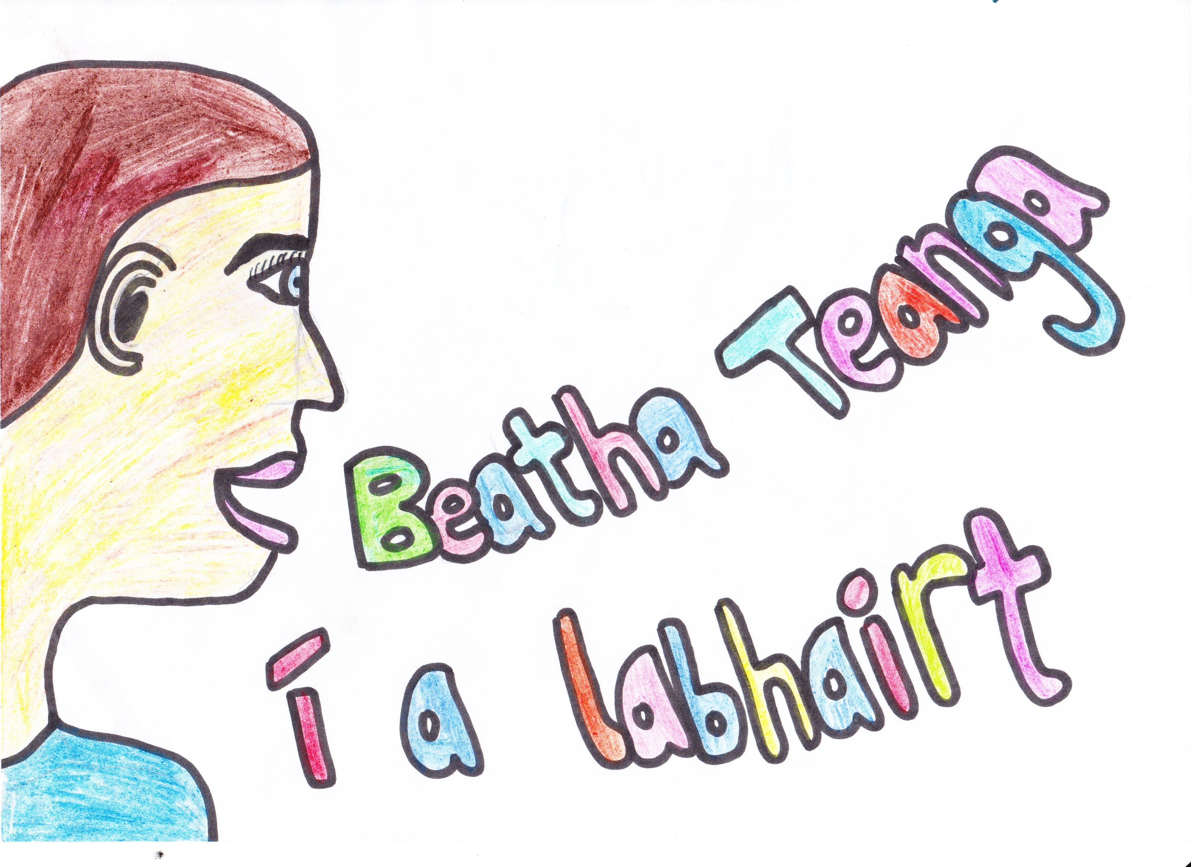 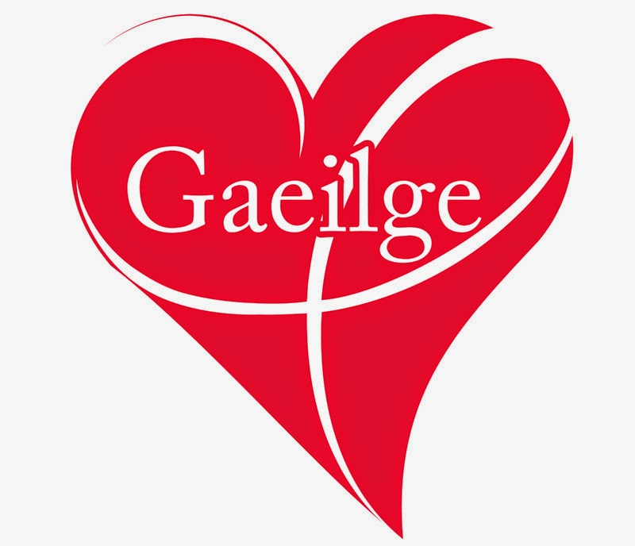 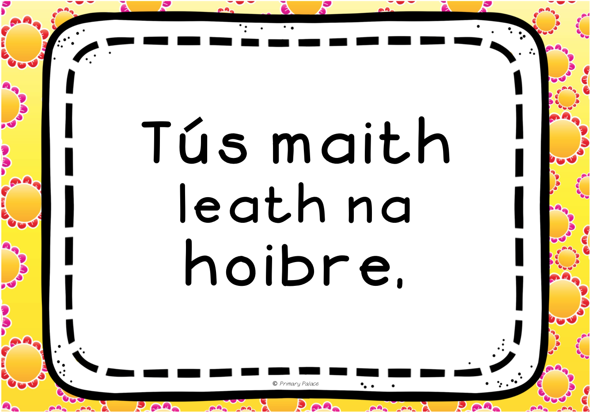



School Closures

**Easter Holidays** Closing on Friday April 12th at 12 noon.

Re-opening on Monday April 29th

**Referendum – Closed as polling station**  *to be confirmed* Friday May 24th

**First Holy Communion** Saturday May 25th.

CONTACT DETAILS

St. Conleth’s National School, Derrinturn, Carbury, Co. Kildare.

Tel: 046 9553490

E-mail: [secretary@stconlethsns.ie](mailto:secretary@stconlethsns.ie)

Website: [www.stconlethsns.weebly.com](http://www.stconlethsns.weebly.com)



**www.stconlethsns.weebly.com**