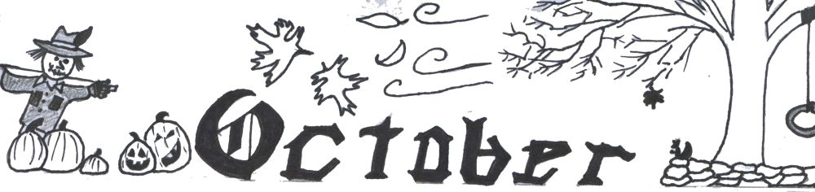

**St. Conleth’s N.S., Derrinturn**

Non-Uniform Day for Parents Association on Friday 11th October.

Please donate €2. All funds raised are used for the children.

**Contents** Non –Uniform Day PAGE 1 Bring & Buy Attendance Advice

Sacramental Dates PAGE 2 Welcoming Parents to School

Coill Dubh A.F.C. Gift PAGE 3

Green Schools News PAGE 4 Internet Safety Talk Contact Details

**Bring & Buy** This month, 6th Class children are very busy preparing for the annual Bring & Buy Sale. It will be held on October 25th. If you have any donations please send them to school. WE collect toys , games, books, bric-a-brac etc. We would also love for people to bake for us so that we can have a bake sale on the day. This is always a great day. This year’s funds will go towards playground enhancements, which will benefit all the children. We thank you in advance for your support and generosity. This day is always one of the highlights of the year.

**Attendance Advice**  Part of our DEIS plan focusses on improving school attendance. We are very proud of our attendance statistics, but we have noticed that a pattern of late arrival and early collection is emerging. It is vital that children attend school for the full day so that they have access to the entire curriculum and all the activities that our children enjoy. The following advice lists how you can promote good attendance habits by: • refraining, if at all possible, from taking holidays during school time. • ensuring regular and punctual school attendance. • making sure that your child stays in school until finishing time each day. • informing the school by writing in the school journal the reasons for absence from school . • working with the School and education welfare service to resolve any attendance problems. • making sure that children understand that parents support good school attendance. • discussing planned absences with the school. • showing an interest in the children’s school day and homework. • encouraging them to participate in school activities. • praising and encouraging their children’s achievements. • instilling in the children a positive self-concept and a positive sense of self-worth. • instilling in the children a positive image of the school. • encouraging a pride in being a pupil of St. Conleth’s National School. • ensuring, insofar as is possible, that children’s appointments (with dentists etc), are arranged for times outside of school hours. • contacting the school immediately, if you have concerns about absence or other related school matters. • notifying, in writing, the school if a child/children, particularly children in junior classes, are to be collected by someone not known to the teacher.

**We thank you for your ongoing support and cooperation. Our children are our priority.**

**Sacramental Dates.**

The dates for sacraments are as follows:-

Enrolment Ceremony for 6th Class: 30th November 2019 @ 11am Mass

Ceremony of Light for 6th Class: 9th February 2020 @ 11am Mass

Confessions for 6th Class: 27th February 2020 after 9.30am Mass

Confirmation: 29th February 2020 @ 11am

First Confession for 2nd Class: 11th March 2020 @7.30pm

First Holy Communion: 23rd May 2020 @ 11am.

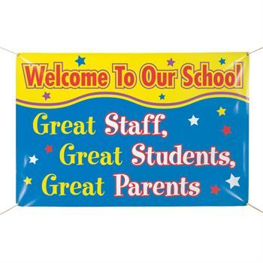

**Welcoming Parents to School** We thank all the parents for attending our homework information evenings in September. We have always held an information night for new Junior Infants, but this year we thought it would be helpful to welcome parents to find out about homework in the different classrooms. It gave us a chance to meet and get to know each other. It also gave you a chance to see the classrooms, in which your children spend so much of their days. We thank you for accepting the invitation to the school and we look forward to a great year of working together to support the children.

During Maths Week, which starts on October 14th, many of you will be invited to attend school to participate in Numeracy activities with the children. The teachers have been really busy preparing Maths Trails and Maths for Fun sessions. Many of our classes are involved and we look forward to welcoming you to school once again. Maths Week is a national festival dedicated to raising awareness and appreciation of maths and numeracy among young people, parents and the wider population. Over 400,000 people, including students and the general public, will take part in events across the island focused on driving home the benefits of maths and all the opportunities it brings for individuals, society and the economy. Now in its 14th year, Maths Week Ireland continues to be the largest festival of maths in the world. St. Conleth’s National School is proud to be a part of this week and we look forward to sharing teaching and learning experiences with the children, as we work with you, the parents on fun and engaging Maths activities.

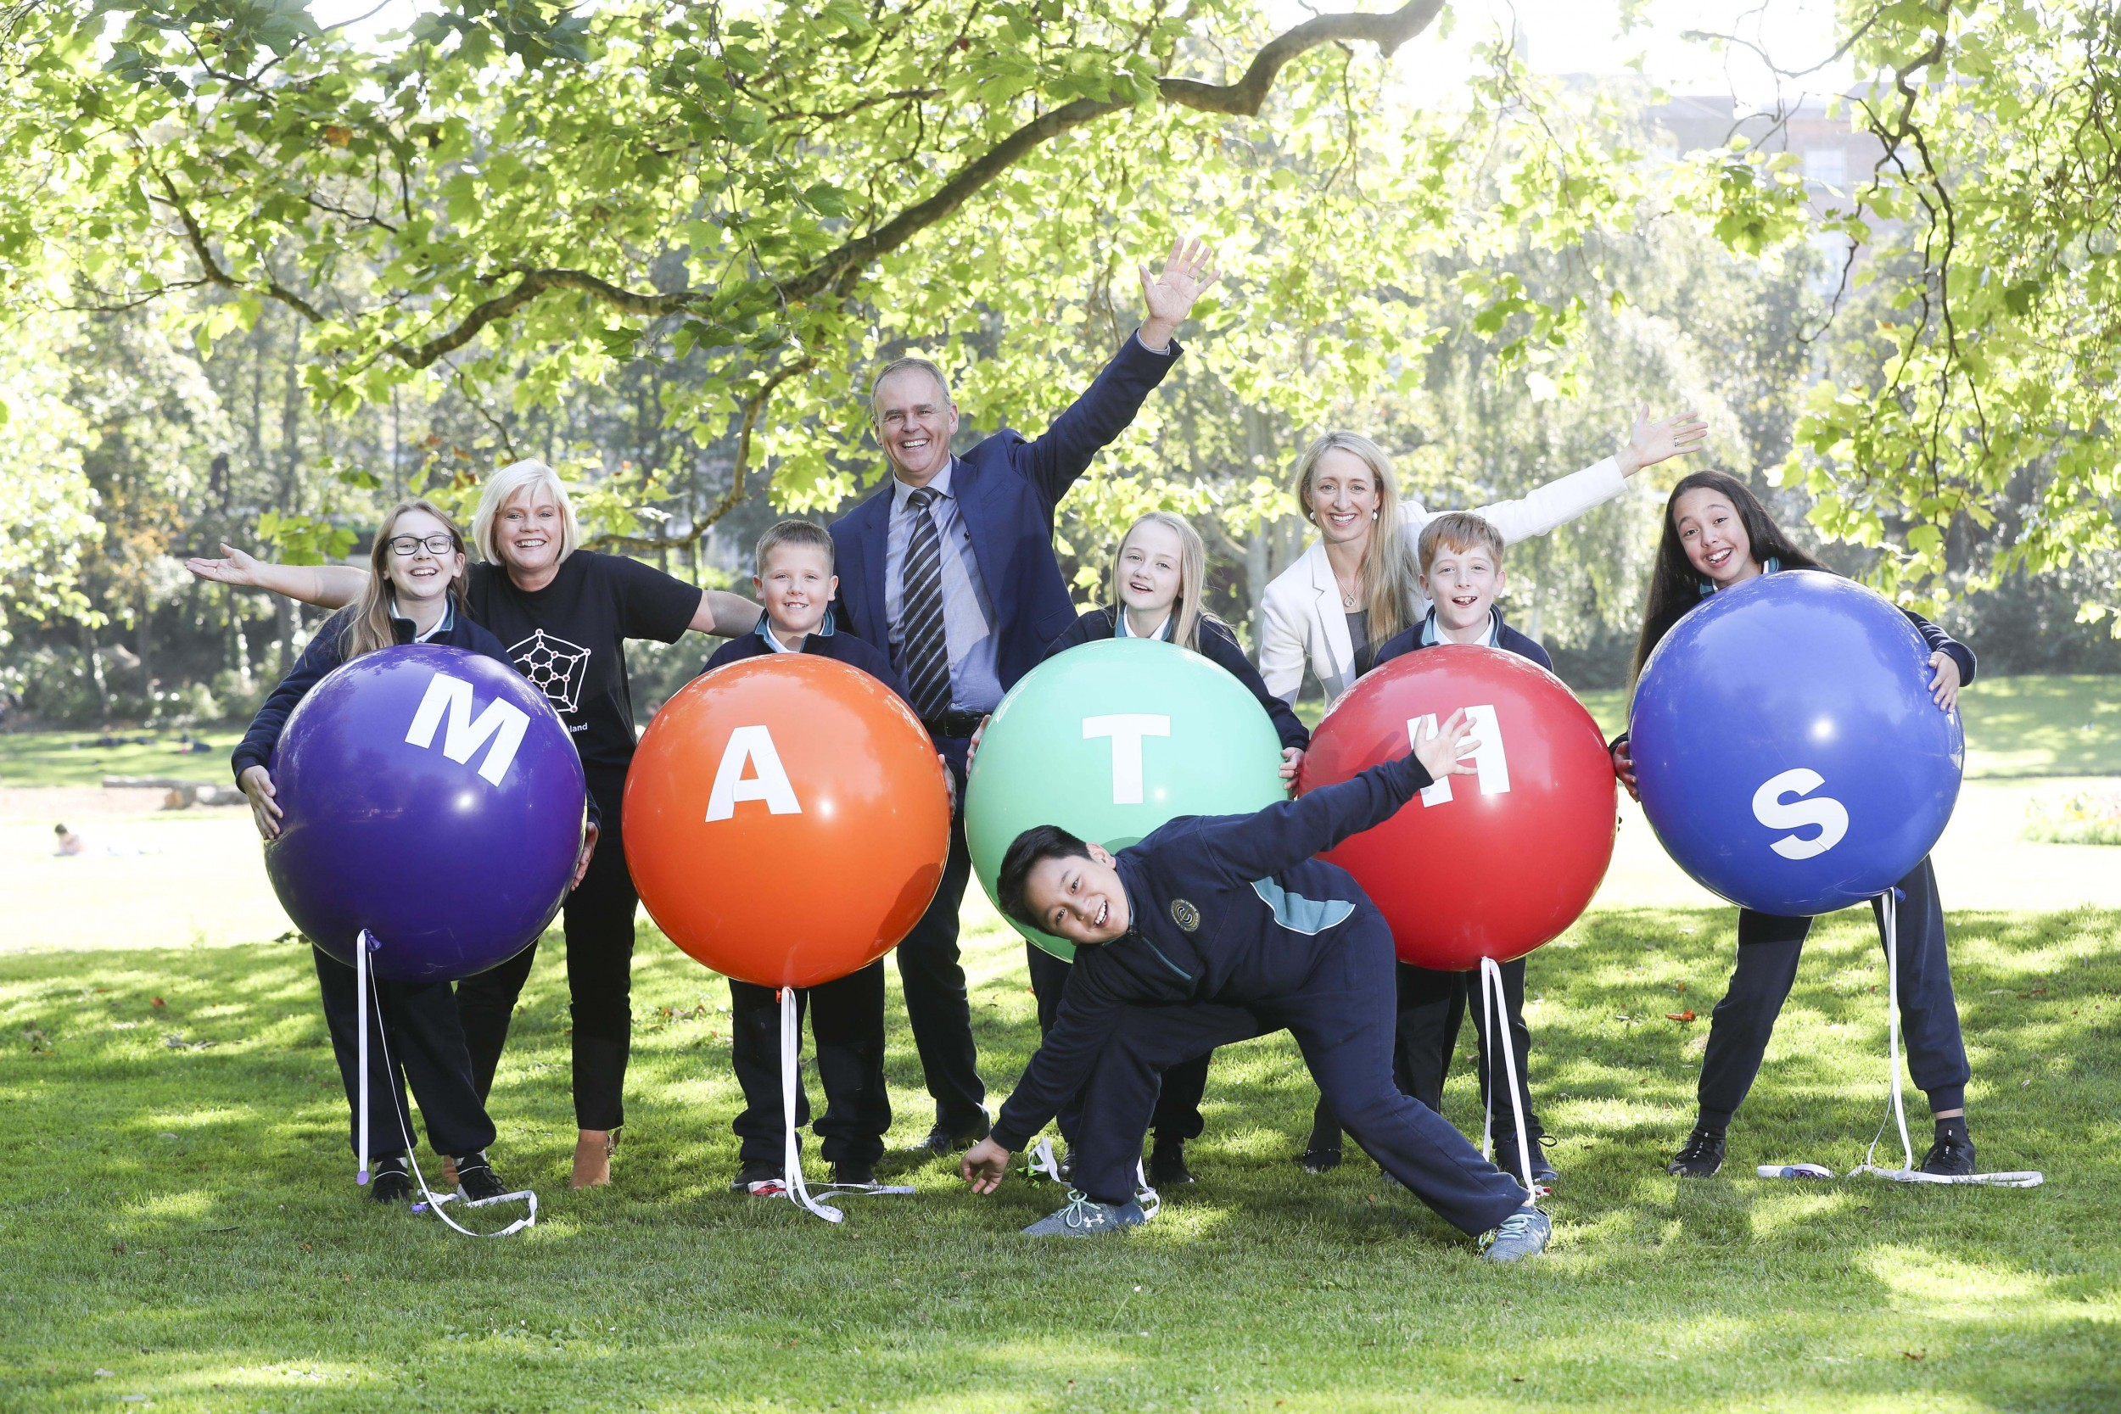

Education and Skills Minister, Joe McHugh T.D. launches Maths Week 2019 with Dr. Sheila Donegan of Maths Week Ireland, Dr. Ruth Freeman, Director of Science for Society, Science Foundation Ireland and pupils from St. Christopher’s Primary School, Haddington Road in Dublin.

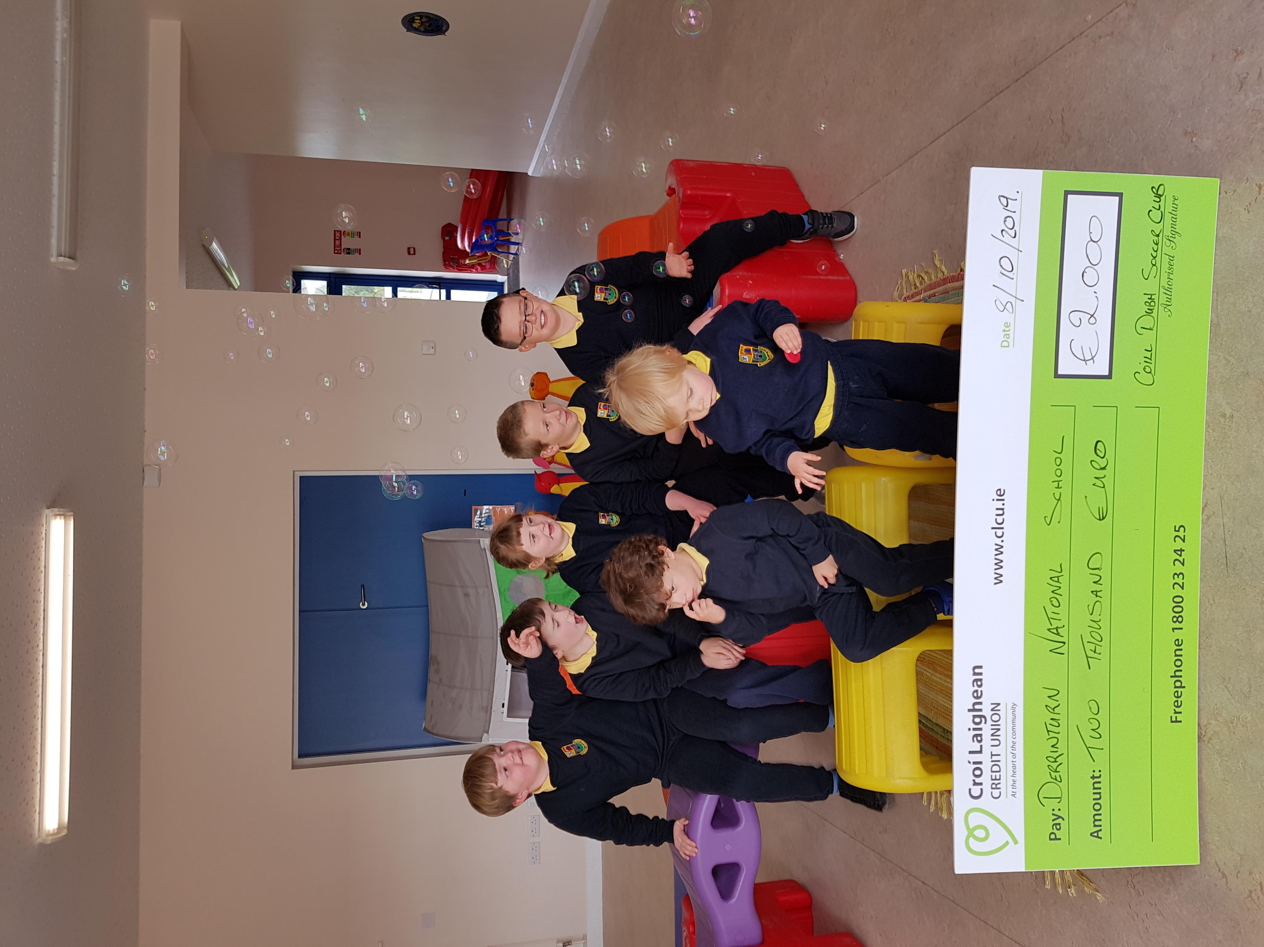

The Síolta and Síoga A.S.D. classes were celebrating on Tuesday October 8th, when a cheque for €2000 was presented to them on behalf of Coill Dubh A.F.C. The soccer club organised a family fun day during the summer to raise much needed funds for a developing club. They decided to use some of the funds raised to benefit the special classes in some of the local schools. Staff from Coill Dubh National School and our school attended a presentation on Tuesday October 8th and the cheque was presented to us. We thank all the organisers of the event and everyone that supported the event. This money will be used wisely. Keep an eye on the newsletters and we will publish photos showing exactly how the money has been used.

We extend particular thanks to Jennifer Brereton, one of our parents, who has worked tirelessly with the soccer club organising this event and many others. The club are embarking on coaching training to ensure inclusive programmes for all children and as this progresses, we will keep you informed.



Thanks to Coill Dubh A.F.C. for a generous donation of €2000 for our Síolta & Síoga classes.

Hip, Hip, Hooray!

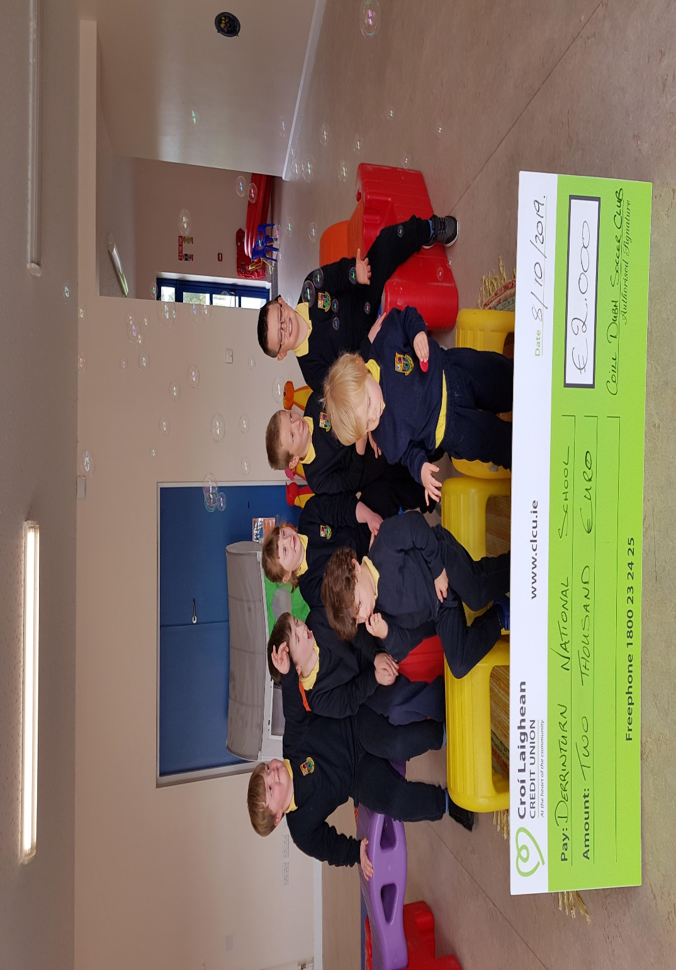

That’s a lot of money! Thanks!

**Green Schools News**

This year, we will be working hard for yet another green flag. Our theme is Global citizenship Energy. We want to raise awareness on how looking after our local environment aids people all over the world. We want to promote and facilitate active citizenship and aim to make further improvement in the energy management in our school. Our committee for the year consists of children from each class; some have been working on this theme before. Committee Members: Liam Grogan, Sophie Glennon, Saoirse Mc Nally, Emma Creggy Long, Lilly Byrne, Kelsey Boyle, Evan Connolly, Rhys Cadogan, Ella Byrne, Sarah Corrigan, Jamie Carberry and Evan Moore. We have made a timetable up for the next few months to revise the previous themes also. Our first flag to revise is Litter and Waste. Our aim is to cut down on our school litter and waste and promote recycling as much as possible. We will be reminding all classes that children are to take their lunch litter home with them and only school waste is to go into our school bins. Also a huge topic at the moment is plastic pollution, I am sure we have all seen the graphic images of plastic pollution in our seas. We have decided as a school to complete a little project, just to see how much plastic waste we as a school create in one week. From Friday, we will be collecting all empty plastic bottles from the children. Mr Farrell’s class will collect them each day and they will display the results the following Friday so we can all see the results. We will keep you posted on this project. Sixth class travelled to Lullymore heritage centre on a fieldtrip on the 19th of September. They had a wonderful experience learning about biodiversity and out our local bogs. They have been working hard on the topic since and have an excellent project displayed on the green school notice board. We would like to thank members of the community garden who along with the help of 4th class planted beautiful winter flowers at the front of our school. It really brightens the place up!

**iNet Safety Talk**

**St. Conleth’s National School Derrinturn**

**Parents Association**

invites all parents and guardians to an

**“Internet Safety & Anti-Cyberbullying”**

**Parent Information Evening**

On Thursday 17th October from

7-9 pm in St. Conleth’s NS Derrinturn

Guest Speaker: Ger Brick

(A former IT Manager at Microsoft who specialises in Internet Safety)

CONTACT DETAILS St. Conleth’s National School Derrinturn, Carbury, Co. Kildare. W91 KC79

Tel: 046 9553490 E-mail: [secretary@stconlethsns.ie](mailto:secretary@stconlethsns.ie)

Please note: Our website is being updated at the moment and will be available before Halloween.

