Newsletter April 2018.

Scoil Chonnlaodh Naofa, Doire an tSoirn.



**Contents** **PAGE 1:** Our Petition Box; Child Safeguarding Statement

**PAGE 2:** Sports Update

**PAGE 3**: Green Schools News; School Self- Evaluation

**PAGE 4:** Dates for Your Diary; School Tours; Contact Details.

**Our Petition Box**

The World Meeting of Families will take place in Dublin on 21st August 2018. A special icon of the Holy Family was commissioned for the occasion and this icon is currently travelling the country, visiting a few churches in every diocese. Each diocese also has its own Petition Box. The Icon will visit the Diocese of Kildare & Leighlin, accompanied by the petition box as follows:- Carlow Cathedral: 27th – 30th April Portlaoise Parish: 30th April – 3rd May Newbridge Parish: 3rd - 7th May The Icon then moves on to another diocese. The Petition Box will come to Carbury for a few days, where it will visit both churches in the parish. We hope everyone will visit the church to place a petition in the box for their families. We also have a box in school. Any petitions in the box will be sent to the diocesan Petition Box so that they can be brought to the World Meeting of Families in August. If you miss the opportunity to see the Diocesan Petition Box, you are welcome to use our school Petition Box.

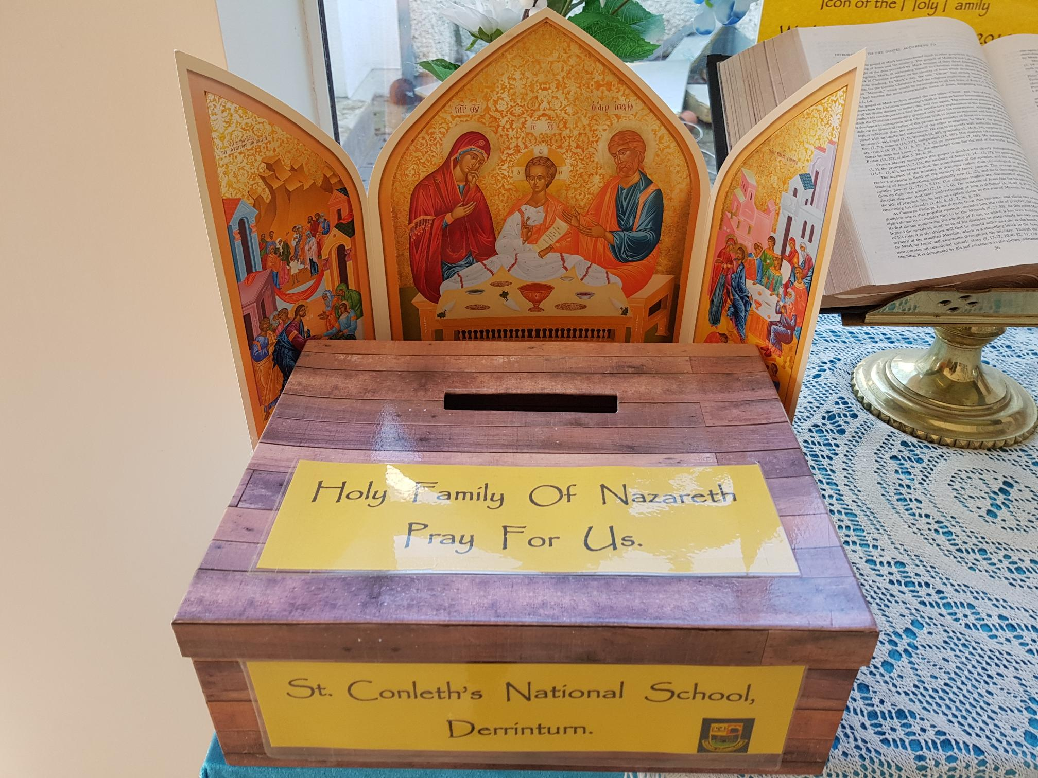

**The Safeguarding Children Statement of St. Conleth’s National School has now been published on our website www.stconlethsns.weebly.com.**

**A Busy Term of Sport Ahead!**

Swimming

A return to school after the Easter holidays heralded the start of our ever-popular swimming lessons in Edenderry Swimming Pool. All children from 2nd to 6th class have 6 weeks of lessons. Our young novices from 1st classes have three weeks of taster sessions this year and are so excited to be getting on the bus every Wednesday like their older counterparts!!

Gaelic Football

Our under 10 team kicked off a busy start to the Cumann na mBunscol Gaelic Football Competitions on Thursday April 12th with a home game to Scoil Naomh Uí Uilig, Newbridge. For many of these youngsters, they were playing for the school for the first time. Determined to the end and showing such enthusiasm for the game and lovely skills, alas they lost on the day. With undampened spirits, the boys and girls from 3rd (and some 2nd) again took to the field away to Clogherinkoe. Displaying more of that determination yet losing on the day, their smiles and delight to travel on the bus and play for their school makes it all worthwhile. They were rewarded for all their hard work on April 26th, when they were victorious in their match against Allen National School. A big thank you to team coach, Mr. Farrell and a huge well done to all the players.

Our Senior Boys under the experienced guidance of Mrs. Colleary took to the field on Tuesday April 17th in an away game to Cappagh. They recorded a most impressive win showing a great display of football, dominance and teamskills. We wish the team the best of luck in their remaining games against Clogherinkoe and Allenwood.

The Senior Girls team also recorded a win in their opening game against St. Mochua’s, Celbridge. Although maintaining control and possession for most of the game, scores were hard to come by. With lovely support play and super determination, goals from Cara Kenny, Lara Brennan and Eva Casey and a point from Keri O’Neill secured the win. A very positive team performance from the girls! Well done and good luck in your remaining games.

Cross-Country Running

On a surprisingly warm and sunny day in Hawkfield last Friday, the annual Cumann na mBunscol cross-country event took place. This event draws a huge volume of entries from schools throughout Kildare. Our team consisted of Illán Kelly, Eoin Cully, Ryan Connolly, Paul Fleming, Cameron Mullen and Tom Norton. The boys ran a super race and put in a great performance. Led home by Illán Kelly , Paul, Eoin, Cameron, Ryan and Tom followed close behind to record a creditable fourth place in the team competition. Well done boys. You represented your school with pride!!

Upcoming events:

Active School Week in May and Sports Day are in the planning phase at the moment. Dates will soon be confirmed and we will let everybody know.

**Under 10 Team.**

Sarah Corrigan, Roisa Kenny, Pauric Weston, Katie Byrne, James Carty, Erin Prendergast, Cillian Casey, Joe Norton, Ryan Hurst, Adam O’ Reilly, Isabelle Cullen, Sarah Cooney, Ruby Murray, Marc Dwyer, Ria Kelly, Ryan Carberry, Ryan Daniels, Jack Byrne, Fionn Kelly.

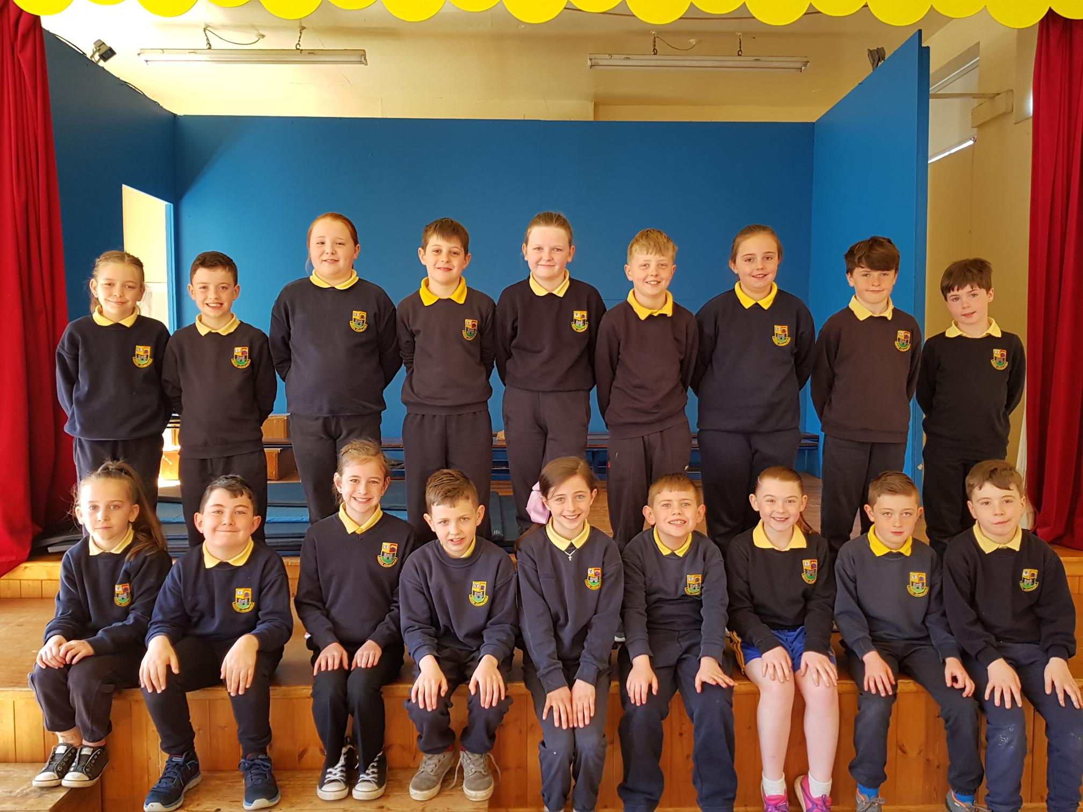

**Green Schools News**

Our current theme for Green Schools is **‘Global Citizenship: Energy’.** This theme gives us a chance to revise the Energy theme, while looking at issues surrounding energy on a global scale.

The most obvious global link is of course, Climate Change. This is the most serious environmental problem of our time and is intrinsically linked to our energy use. The problems associated with climate change are vast, and they impact both the environment and people all over the world, in particular people in developing countries. Due to its global nature, the consequences of climate change are profound and far-reaching and have an impact on every aspect of life on earth.

Some of the potential impacts of climate change are:- Changes in rainfall pattern Sea level rises An increase in droughts Habitat loss Heat stress The number and intensity of extreme weather events Decline in farming productivity

Each of these could potentially cause serious problems. We are already seeing changes in our weather. What a year for us to choose to start talking about Climate Change in school? The weather here in Ireland has been useful in our lessons!

We thought we’d take time this month to thank our hard-working team on the Green Schools Committee and to introduce them to you all.

**Green Schools Committee 2017 – 2018**

Emma Creggy Long Rhys Cadogen

Adam Carey Lilly Byrne

Kelsey Boyle Evan Connolly

Ella Byrne Sarah Corrigan

Jamie O’ Connor Evan Moore

Luke Melody Keelan Walsh Dunne

Illan Kelly

**School Self-Evaluation**

It has been decided that schools will re-engage with the process of school self-evaluation as recommended by the Department of Education and Skills. School self-evaluation is a collaborative, inclusive, reflective process of internal school review. It is a way of working that involves reflective enquiry leading to action for improvement that is informed by evidence gathered within each school’s unique context. In order to make re-engagement with school self-evaluation meaningful, you will be asked to participate in surveys and questionnaires over the coming months. These will provide vital analysis and information to guide and steer our focus, as we formulate our School Improvement Plan. The information you provide will form a very important part of our data-gathering as we strive to plan ahead for our school. We look forward to engaging with this process and we are anxious to hear your views.



Friday May 4th: School is closed for the Bank Holiday weekend

Monday May 7th: School is closed for the Bank Holiday weekend

Monday May 14th: Start of Book Fair

Friday June 1st: School is closed for the Bank Holiday weekend

Monday June 4th: School is closed for the Bank Holiday weekend

Tuesday June 26th: Closing for Summer Holidays

**School Tours**

All the teachers have been very busy planning tours for their classes. They have carefully researched all aspects of the tours, keeping cost and value for money in mind. They have considered the interests of the classes and opted for age-appropriate activities and settings. Health and Safety issues have also been debated and the teachers have organised supervision and extra help where necessary. We thank the teachers for all this hard work, which will ensure that we have wonderful class tours. The children eagerly await school tour day every year and it is a wonderful social occasion for them. The school tour is an extension and reinforcement of classroom activities, be it a tour of a museum, a gallery or an adventure centre. We advise you to start sending in tour money now, so that all costs are covered. The class teachers have been haggling with venue organisers and bus companies, to secure the best possible deals. We urge you to avail of the opportunities provided. Detailed letters will be issued by individual teachers as the tour dates approach. Please be mindful of all the details, including what to bring, what to wear, departure and arrival times and any other advice included in the teachers’ notes. It may be necessary to bring both rain gear and sun-screen, such is the nature of our weather. We wish all the children successful tours and we hope they enjoy themselves.

  

www.stconlethsns.weebly.com

nlethsns.

www.stco

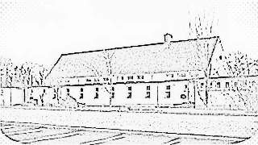

CONTACT DETAILS

St. Conleth’s National School, Derrinturn, Carbury, Co. Kildare.

Tel: 046 9553490

E-mail: [secretary@stconlethsns.ie](mailto:secretary@stconlethsns.ie)

Website: [www.stconlethsns.weebly.com](http://www.stconlethsns.weebly.com)