February 2018 Newsletter.

St. Conleth’s National School, Derrinturn.



**Contents** **PAGE 1:** World Autism Awareness Day

**PAGE 2:** Safeguarding Children Updates; Erasmus News.

**PAGE 3**: Trócaire; Seachtain na Gaeilge.

**PAGE 4:** Dates for Your Diary; The School Website; Contact Details.

**World Autism Awareness Day**

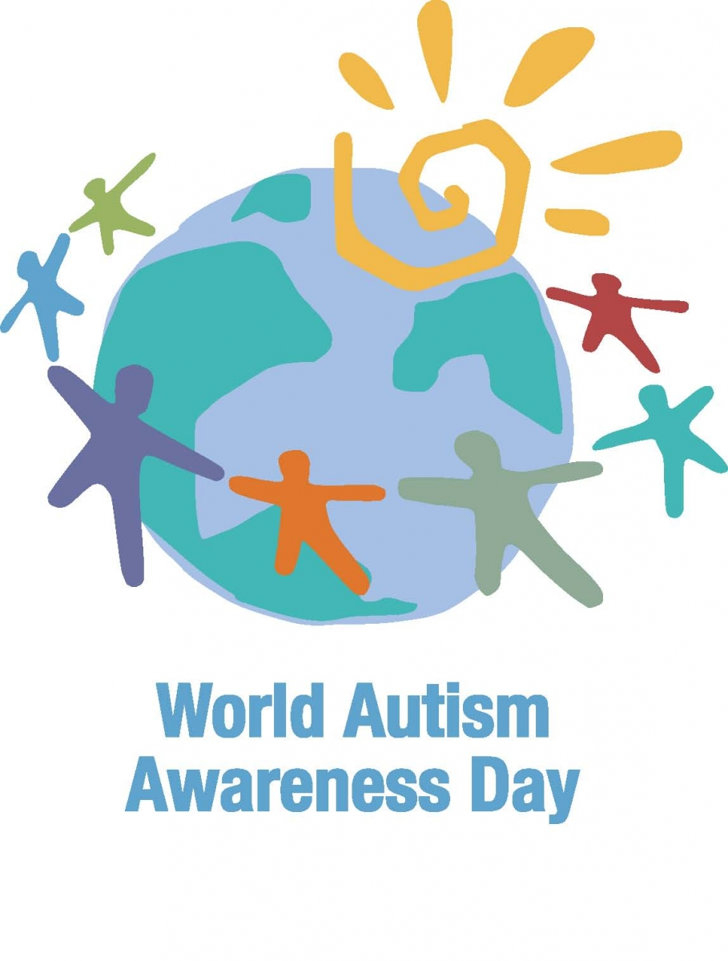

The eleventh annual World Autism Awareness Day is on Monday April 2nd 2014. World Autism Awareness Day (WAAD) aims to put a spotlight on the hurdles that people with autism – and others living with autism – face every day. Additionally, World Autism Awareness Day goes one step further to celebrate the unique talents of those with autism, while putting a huge focus on the warm embrace and welcome that these skills deserve.

Unfortunately, the school will not be open on World Autism Awareness Day. We will have our Easter holidays at that time. However, in light of the fact that we have a number of children with autism at our school, the staff have decided to do something very special to mark this very important day. We are going to have a ‘Blue Day’ on March 23rd

. Children throughout the school may dress in the colour blue and make a donation towards our Blue Day Fund on the day.

We thank you for your support!

Best wishes to the children in 6th Class as they make their Confirmation on Saturday March 3rd 2018.

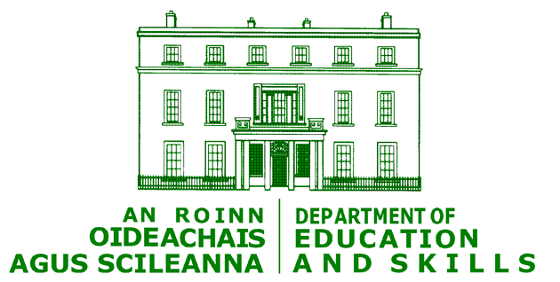 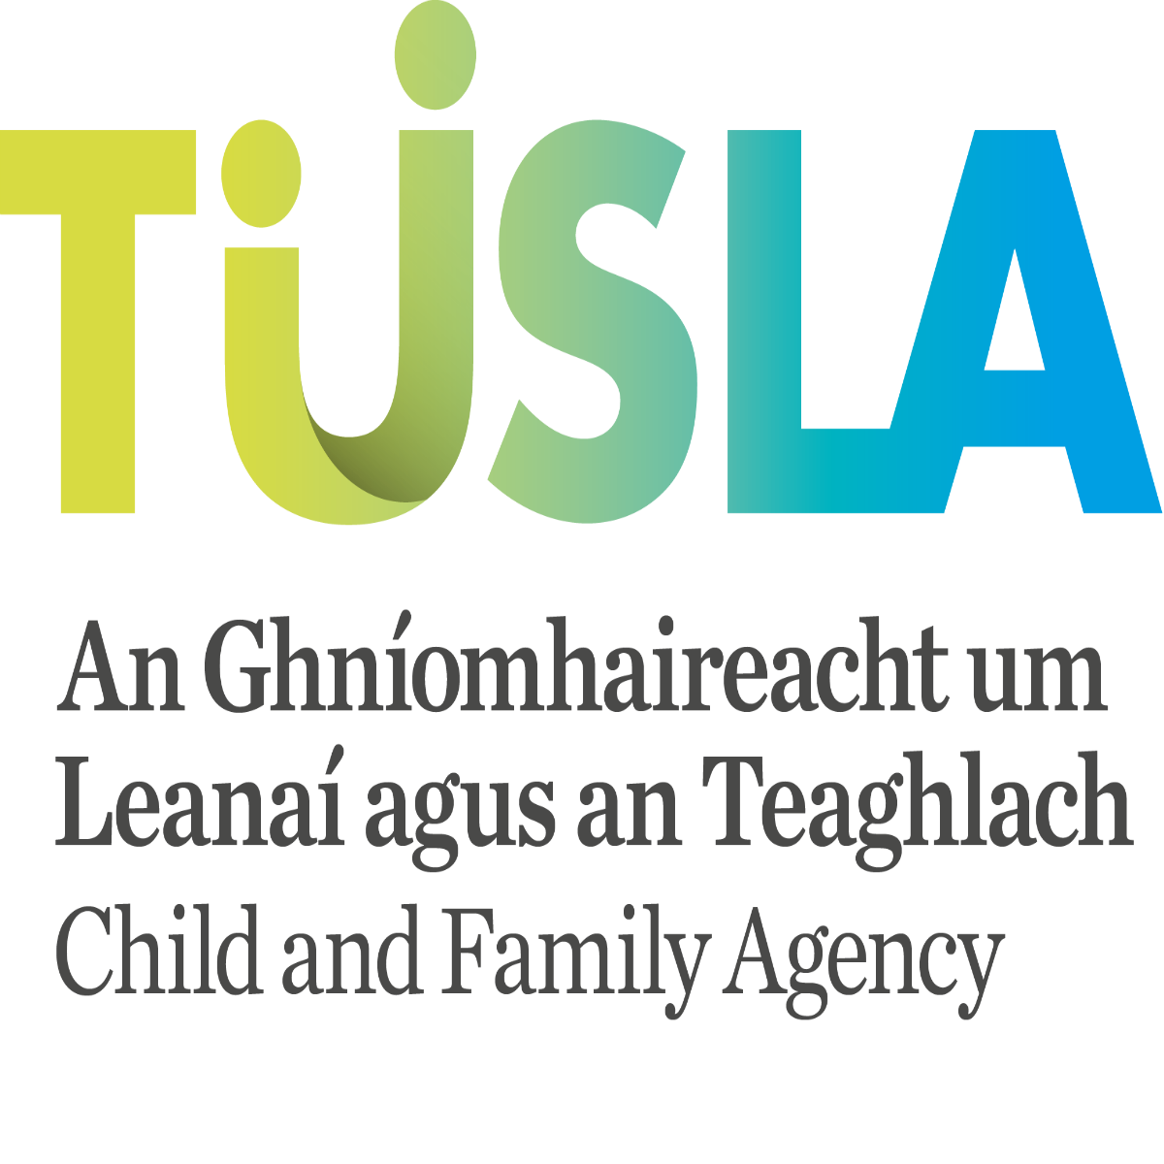

**Safeguarding Children Updates**

The [Children First Act 2015](http://www.irishstatutebook.ie/eli/2015/act/36/enacted/en/pdf), which was signed into law on 19 November 2015, puts elements of the Children First: National Guidance for the Protection and Welfare of Children on a statutory footing. The legislation was a key Programme for Government commitment, and forms part of a suite of child protection legislation which includes the National Vetting Bureau Acts, 2012-2016 and the Criminal Justice Act 2012.

The Act provides for a number of key child protection measures, as follows:  
  
•    A requirement on organisations providing services to children to keep children safe from harm and to produce a Child Safeguarding Statement;  
•    A requirement on defined categories of persons (mandated persons) to report child protection concerns over a defined threshold to the Child and Family Agency;  
•    A requirement on mandated persons to assist the Child and Family Agency in the assessment of a child protection risk, if requested to do so by the Agency;  
•    Putting the Children First Interdepartmental Implementation Group on a statutory footing.

A directive has issued from the Department of Education and Skills, instructing all schools to close on two occasions to facilitate training for all school staff in new Child Protection and Safeguarding Children procedures. The training is mandatory for all school staff as per the’ 2017 Children First National Guidance for the Protection and Welfare of Children’ and the ‘2017 DES Child Protection Procedures for Primary and Post Primary Schools.’ Our first closure is for a half day on February 27th. Children will finish school at 12.30 on that day. A second half day will be taken later in the year and notice will issue to all parents in advance of this.

The school is in the process of preparing a Safeguarding Statement and this will be published on the school website.

**Erasmus News.**

Our Erasmus project is well under way at this stage. So far the children from third and fourth classes have sent and received Christmas cards from their peers in our partner countries. At the beginning of February, letters were sent to the schools as well. These letters told the children in the other countries all about our school, our country and our interests. We should soon have responses to these letters and the children are very excited about communicating with our friends in other places.

A design competition was also held in these classes to create a robot character as the mascot for the project website. Children from all the different countries have entered. We cannot wait to see if one of our designs has been selected. Fingers crossed!

During March, 5th and 6th classes will commence project work on the three continental partner countries, Finland, Italy and Spain. We are anxious to learn more about our Erasmus friends and their lives.



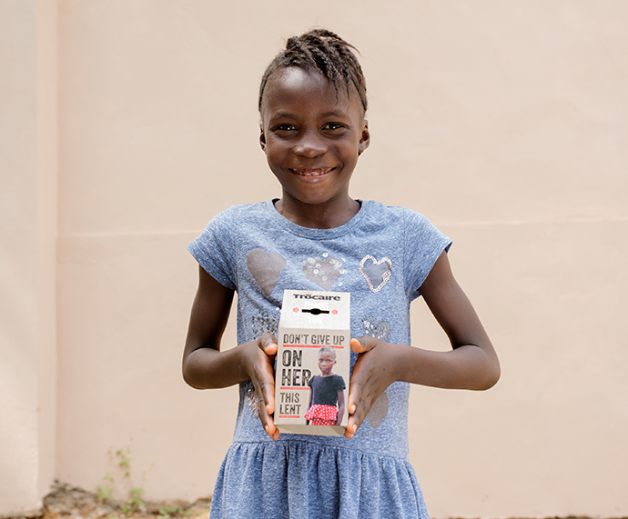 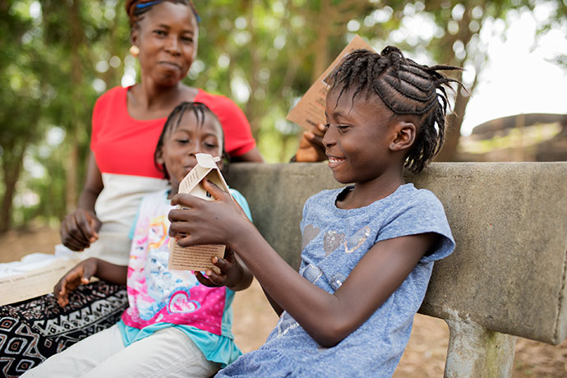

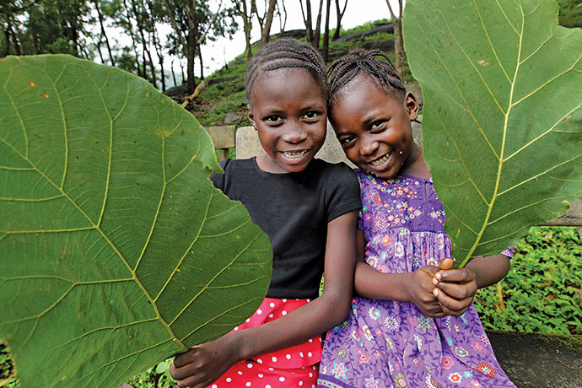

This year the Trócaire box tells the story of Kumba, a seven-year-old girl from Sierra Leone. At the age of just seven, Kumba has already survived an Ebola outbreak that killed 4,000 people and a mudslide that killed 1,000 people. Her young life has been spent in an almost constant state of crisis. Tragically, she is far from alone. A seven-year-old in Syria has never known peace; a seven-year-old in Gaza has survived two separate wars; a seven-year-old in South Sudan has experienced both famine and civil war in their short life. The Lenten campaign comes at a time when conflict in many parts of the world has left millions of people at risk of famine and disease. The work Trócaire does promoting human rights, women’s empowerment and access to resources such as land and water is key to building strong and peaceful societies. That work is powered by our annual Lenten appeal. We will use donations to our campaign to support over two million of the poorest and most vulnerable people around the world this year. Please support Trócaire this Lent.

Seachtain na Gaeilge

Seachtain na Gaeilge will run from March 12th until St. Patrick’s Day. The week will be filled with events and activities that celebrate everything about being Irish. Children will speak Irish and take part in cultural and musical activities. We encourage you all to try the ‘cúpla focail.’ Bain triail aistí agus bain taitneamh aistí!

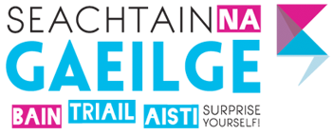



Tuesday 27th February: Half Day for Staff Training

Saturday 3rd March: Confirmation

Thursday 15th March: First Confession

Monday March 12th: Start of Seachtain na Gaeilge

Monday March 19th: Closed for Public Holiday

Friday 23rd March: Closing for Easter Holidays

**The School Website**

The website is still in its infancy, but important information is available. We will be able to keep our new website more current and we can upload information very quickly. Please visit [**www.stconlethsns.weebly.com**](http://www.stconlethsns.weebly.com)**.** Please type this into the url box. This will bring you to the site quicker than using a search engine. We hope to keep you up to date with our new website. If you have any suggestions for the site, please let us know.

  

CONTACT DETAILS

St. Conleth’s National School, Derrinturn, Carbury, Co. Kildare.

Tel: 046 9553490

E-mail: [secretary@stconlethsns.ie](mailto:secretary@stconlethsns.ie)

Website: [www.stconlethsns.weebly.com](http://www.stconlethsns.weebly.com)

www.stconlethsns.weebly.com

nlethsns.

www.stco

