September 2017 Newsletter.

St. Conleth’s National School, Derrinturn.



**Uniform Exchange.**

**Contents** Uniform Exchange p. 1

Welcome Back p. 1

Special Educational Needs p. 2

Aistear p. 3

Traffic Management p. 4

Dates to Remember p. 4

Contacts p. 4

 The Uniform Exchange facility remains available at the school entrance until Friday 29th September.

Giving & Getting!

Drop & Swap!

**Welcome Back!** I take this opportunity to welcome everybody back for the new school year. We are all refreshed and energised and looking forward to a great year. There are several new initiatives at school this year and they promise to be productive and fulfilling. Among these are a new model for Special Educational Needs delivery and Aistear. Articles in this newsletter give greater detail on both of these programmes. We know that working in partnership with the parents and children, we will make excellent progress and achieve great results for our children. Your support and cooperation in the past has proven this. The Uniform Exchange was a great success during the holidays and uniforms will remain available at the school entrance until Friday September 29th. Please feel free to avail of the service. Donations of uniform items will be gratefully accepted until the end of September. Feel free to come in and ‘adopt’ uniforms should you need to. We hope to reduce costs for parents by providing this drop-off, pick-up facility. The flat roof is undergoing a major face-lift at the moment. We apologise for any inconvenience that this may cause, but the work is necessary. It isn’t just cosmetic, but functional as well. The roof is being insulated to conserve energy and cut down on heating costs. We hope to have completed the renovations soon and we thank you for your patience while this important work proceeds. Unfortunately the school roof has become a playground for some teenagers. The Gardaí are aware of this and will patrol the area. Just like our building, our new website is under construction. The new website will allow us to update immediately and we will be in a better position to keep up to date and inform people of changes, events, achievements etc. We are very excited to be able to have instant control over the content of the website and to be able to effect immediate updates. A text will issue as soon as the website is up and running. We have a few tips for you, as parents starting the school year:- **Your children love you and look up to you.** They copy what you do, so please set an example. At school we try to set an example of politeness and consideration. **Please show your children you care about them.** I’m not talking about “I love you” all over the place. When your children get into the car after school, please get off your phone – they want to tell you about the day. **Your**[**children need sleep**](https://www.theguardian.com/lifeandstyle/2013/jul/08/irregular-bedtimes-affect-childrens-brains)**.** Do not let them stay on phones or tablets all night. **Feed your children well.** [Breakfasts matter](https://www.theguardian.com/lifeandstyle/2015/nov/17/healthy-breakfasts-fuel-better-school-results-says-study). Snacks and hydration are needed during the day. **Things** **do go wrong.** We expect you to tell us if you have concerns and we expect to have to deal with all sorts of issues, so don’t let things fester until you’re angry. **Your children may be bullied at some point.** This is the reality, especially in the world of social media. This doesn’t mean the school is unsafe. Children can be cruel to one another. Don’t issue threats on behalf of your child. It’s a bad idea to get into a feud with the other child’s parents. Reassure your child and support the school to resolve the issue. Encourage your child to be kind, not bear a grudge, even if you think they were 100% the victim, and to stand up for their friends. **Social Media can be toxic!** We have a responsibility to reduce the risks to our children. This includes monitoring phones and devices. It’s good parenting and good practice. Have a wonderful year. We are always available. Feel free to make contact with the office.

**Special Educational Needs**

On April 6th 2017, Minister Bruton announced a new model of delivery for Children with Special Educational Needs. The National Council for Special Education (NCSE) Report *Delivery for Pupils with Special Educational Needs* (NCSE 2014), highlighted a number of shortcomings associated with the system for allocating special education teaching resources to schools. On this basis, the NCSE recommended a revised allocation model. Following successful piloting in forty-seven primary and post-primary schools during the 2015-2016 school year, the Department decided to introduce a revised allocation model for all mainstream schools with effect from September 2017. Under the revised model, the Department provides special education teaching supports directly to schools based on their educational profiles (including a baseline component). This offers schools greater autonomy to allocate teaching resources flexibly, based on pupils’ needs, without the requirement for a diagnosis of disability. When allocating teaching resources, we recognise the benefits of early- intervention and prevention programmes and allocate teaching resources as required, based on identified needs and our unique school context. We aim to strike a balance between in-class support, group and individual support. Importantly, the level and type of support will reflect the specific targets of individual pupils as set out in their support plans and be informed by careful monitoring and review of progress. In this way, following a period of intervention, some pupils may no longer require additional teaching supports, some may require the same level, while others may require more intensive supports. At St. Conleth’s National School, we feel that it is vital that effective systems are implemented to identify pupils’ needs and that progress is monitored methodically and periodically. Bearing this in mind, we draw your attention to some of the principles that guide the implementation of the new Special Educational Needs programme.

|  |
| --- |
| **Principles to guide the implementation process**  *(taken from the Guidelines of the Department of Education and Skills)* |
| * Resources provided to support pupils with special educational needs should be used to facilitate the development of truly inclusive schools. * Supports provided to pupils with special educational needs should be based on identified needs and be informed by regular reviews of progress in consultation with parents and pupils. * The class teacher has primary responsibility for the progress and care of all pupils in the classroom, including pupils with special educational needs. |
| * Pupils with the greatest levels of need should have access to the greatest level of support, and whenever possible, these pupils should be supported by teachers with relevant expertise who can provide continuity of support.   As you can see, the class teacher is the first port of call for any queries and/or consultation. If you have concerns for the well-being or development of your child, it is to the class teacher that you should express your concern initially. The Special Educational Needs Team all work together, but there must be structure and communication procedures if the process is to function well.  The Special Educational Needs Team engage each week with class teachers and needs will be addressed as they arise. The class teacher is part of the team working with the individual child. Meetings between parents and members of the team will be arranged and Individual Education Plans will be drawn up, implemented and reviewed in consultation with parents. Good parental engagement is a critical factor in enhancing outcomes for pupils with special educational needs. This is recognised by the school and is seen in the many good practices and initiatives we already use to promote communication between school and home. Parental engagement is enhanced when parents are consulted in relation to their children’s needs and strengths, on the supports and strategies being developed to support their children, and when they are involved in regular reviews of progress. We look forward to providing the best possible support and development plans for your children in consultation with you, the parents. As we commence our journey through the implementation of the new Special Educational Needs programme, we encourage your engagement with the process. Should you have any concerns, please discuss these with the relevant class teacher. The new strategy offers huge potential and we look forward to great progress and success. |





Aistear is the early childhood curriculum framework for all children from birth to six years. The word Aistear is the Irish word for journey and was chosen because early childhood marks the beginning of children’s lifelong learning journeys. We are introducing Aistear to our Junior and Senior Infant classrooms this year. Many of the children are familiar with this methodology from their experiences in pre-school.

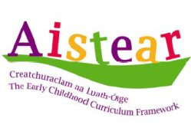

Aistear is a key learning and teaching tool used to implement the primary school curriculum in infant classes. Aistear sessions last for an hour, with an emphasis on active learning and oral language development. Each class is supported by the learning support team during this hour. Curriculum subjects covered during Aistear include: S.E.S.E., S.P.H.E., oral language, reading, writing, maths, art, music and drama.



During the Aistear hour, the children are implementing their numeracy and literacy skills in a more meaningful way through the use of role play, games and real-life situations. As we begin to implement Aistear in our infant classrooms, we will post updates to our new school website. We hope you enjoy browsing through the various activities Junior Infants and Senior Infants have engaged in. For more information on Aistear visit [www.ncca.ie](http://www.ncca.ie) and click on the Aistear logo which you’ll recognise from this page!

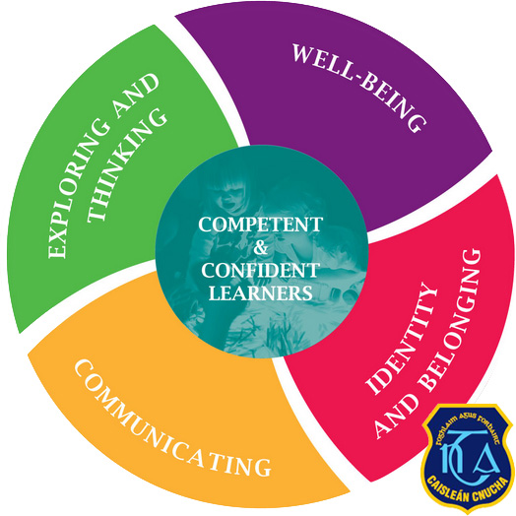



  

Traffic Management.

A new Road Safety Officer will be appointed very soon by Kildare County Council. Declan Keogh has moved to a new position. We wish Declan every success. Our wonderful Warden Leader, Mrs. Curley has also retired. We are waiting to hear if the school warden scheme will continue. In the interim, we ask for your care and attention while dropping off and collecting children at school. Be mindful and aware when driving near the school. Remember that little people are making their way into and out of the grounds. Some of our students are inexperienced. Some are so small that they might not be visible until they step out from behind a car. Allow time for drop-off and collection. Use the two dedicated pedestrian entrances. Pedestrians should not enter via the staff car park. Keep our children safe.



Wednesday 6th September: Closing Date for School Lunch Club forms.

Monday 11th September: School Lunch Club will start.

Monday 18th September: Induction fortnight for Junior Infants and Síolta finishes. These classes will finish at 2pm.

Friday 29th September: Uniform Exchange will close.

Friday 27th October: School closes for Mid-term break.

Monday 6th November: School re-opens.

CONTACTS:  Telephone: 046 9553490

E-mail: [secretary@stconlethsns.ie](mailto:secretary@stconlethsns.ie)



*We regularly contact parents by text message. Please ensure that your text number and all contact details are correctly filed in school. Any changes can be sent to Carol, our school secretary.*