

**✆ Telephone ⓪④⑥ ⑨⑤⑤③④⑨⓪**  [**www.stconlethsns.weebly.com**](http://www.stconlethsns.weebly.com)

 **E-mail: secretary@stconlethsns.ie**

**St. Conleth’s National School, Derrinturn.**

***Scoil Naomh Chonnlaodh, Doire on tSoirn.***

**New Pupil Information Booklet**



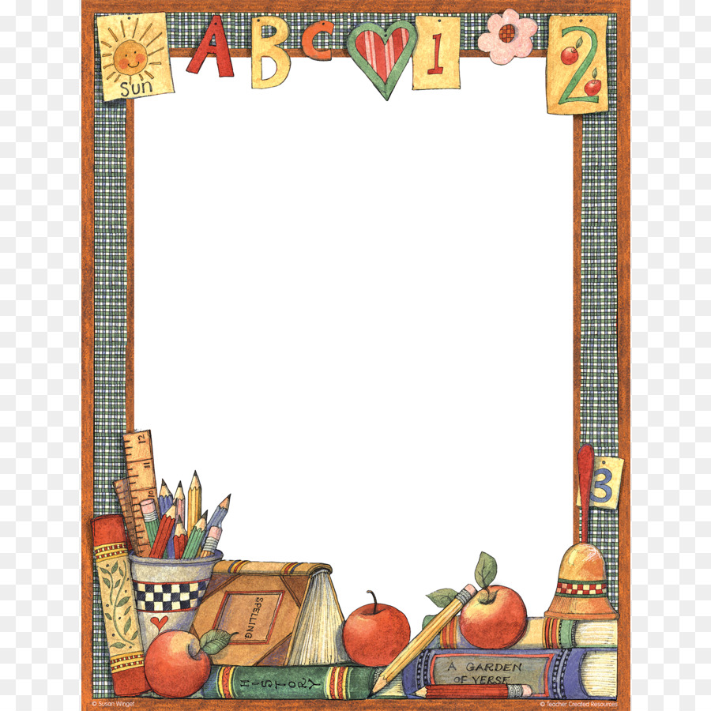

**Contents**

Welcome from the Principal p. 1 The School Day p. 2 Attendance p. 2 Child Protection p. 3 Uniform p. 4 Lunches p. 5 Allergies, Admin. of Medicine, Health Issues p. 6 Communication/Contact Details p. 7 Parental Involvement p. 8 Curriculum and Assessment p. 9 School Books p. 9 Our Mission Statement p. 10 Getting Ready for School p. 11 The Early Days p. 12 School Rules p. 13 Thanks and Contact Details for School p. 14



1

 **A Welcome from the Principal** Dear Parents and Guardians,

Fáilte is fichead romhaibh chuig scoil Naomh Chonnlaodh. I take this opportunity to welcome you and your children to St. Conleth’s National School, Derrinturn. We are delighted to share in this wonderful milestone with you and your family and we look forward to introducing your child to the wonderful learning experiences of school life with us.

We are a very busy school community with teaching and learning at the core of everything we do. We pride ourselves on being an inclusive school, where every child is valued and respected. We believe that all children grow and thrive when they are happy and we provide a safe, supportive environment where children can reach their full potential, whatever that might be. The sky is the limit!

We are fortunate to be blessed with a passionate, hard-working and caring staff, comprising teachers, special needs assistants, caretaker, secretary, cleaners, bus escorts and volunteers. The Board of Management and the Parents Association also provide great support to the school on a voluntary basis and are always generous with their time. We are a community of learners, working together to provide the best possible education to our students.

I wish to emphasise the importance of communication, if you have any concerns, your child’s class teacher is always there to listen and support and he/she should always be the first port of call. I look forward to meeting with you all over the coming months and I hope you enjoy your journey with us here in St. Conleth’s National School. We hope that you will find this information booklet helpful. Should you have any queries relating to school life here, please do not hesitate to ask.

Le gach dea-ghuí,

Mrs. Finnuala Kirk

Principal.

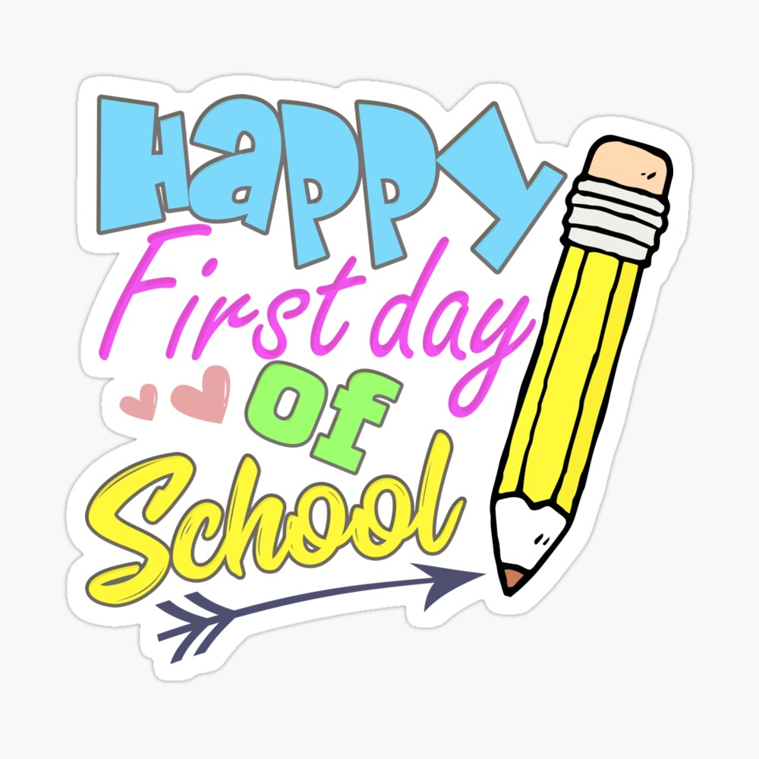

**Attendance**



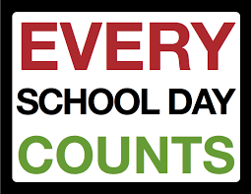

**The School Day**

 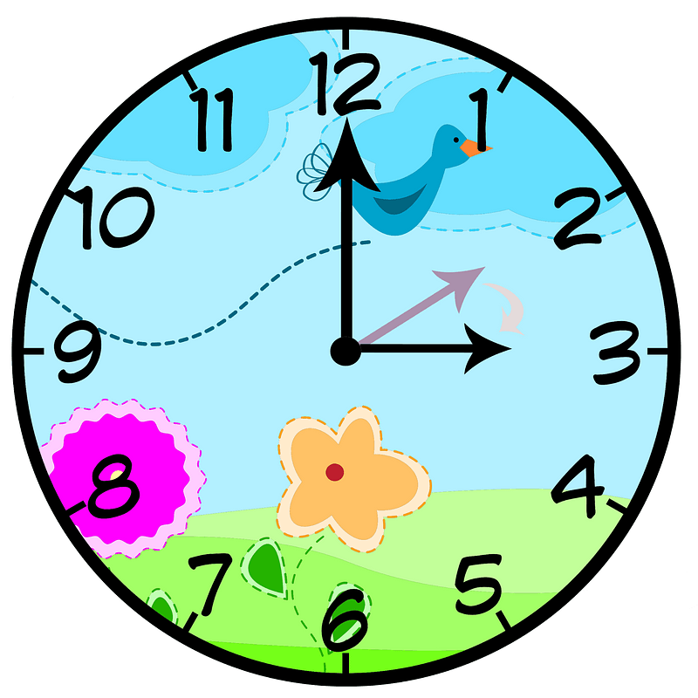

School begins at 9.20am Junior and Senior Infants and our Síolta Early Intervention class go home at 2pm. Pupils from first class to sixth class go home at 3pm.

Please note that Junior Infants will have an induction timetable for the first two weeks of the school year. They will finish early for these two weeks.

Please ensure that your child is **punctual**. Children miss out on essential social elements of the school day if they are late. It is also important that your child stays until the end of each school day, unless he/she has an appointment.

**Morning Break** is at **11.00 – 11.10am**

**Lunch Break** is at **12.45pm – 1.15pm**

The school calendar for the year is available on the school website,[**www.stconlethsns.weebly.com**](http://www.stconlethsns.weebly.com)It is also on display in the foyer at the school office window.

Your child **should** attend school every day. All schools have an obligation to report absences of twenty days or more to Tusla’s Education Support Service. Please phone or e-mail the school or write a note to the teacher when your child is absent.

For safety reasons, children are not released during school hours to anyone except parents/guardians or a nominated party. Please inform the school office if you are nominating another person to collect your child from school. Children should only be collected early if it is absolutely necessary. If your child is ill, please do not send him/her to school. We have learned difficult lessons recently about infections and rates of transmission. We can protect each other by staying at home if we display symptoms of any illness.

Take your doctor’s advice regarding illness, rashes, ongoing conditions etc.

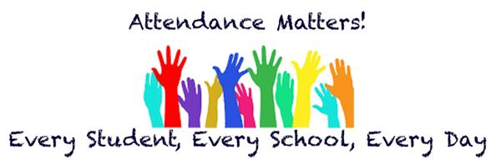

2

In recent years, as a society, we have become very aware of the problem of child abuse. Each one of us has a duty to protect children. Teachers are mandated persons. The Children First National Guidance for the Protection and Welfare of Children 2017 states that mandated persons are people who have contact with children and/or families and who, because of their qualifications, training and/or employment role, are in a key position to help protect children from harm. Mandated persons have legal obligations to report to Tusla.

The Department of Education and Skills published Child Protection Procedures for Primary and Post-Primary Schools in 2017. These procedures promote the safety and welfare of children and are welcomed. The Board of Management of St. Conleth’s National School has adopted these procedures as school policy. Consequently, staff members work as mandated persons and inform Tusla when there are reasonable grounds for concern that a child may have been, is being, or is at risk of being abused or neglected. Tusla assess concerns that are reported to them.

In our school the Designated Liaison Person for dealing with Child Protection issues is the school Principal, Mrs. Kirk. The Deputy Designated Liaison Person is the Deputy Principal, Mrs. O’ Donoghue.

The Children First National Guidance for the Protection and Welfare of Children 2017 is available on the website of the Department of Children and Youth Affairs. ([www.dcya.ie](http://www.dcya.ie)) Child Protection Procedures for Primary and Post-Primary Schools in 2017 can be accessed on the website of the Department of Education and Skills. ([www.education.ie](http://www.education.ie))

Parents/guardians are also welcome to read through these and the school’s Child Safeguarding Statement and our Risk Assessment Document at the school.

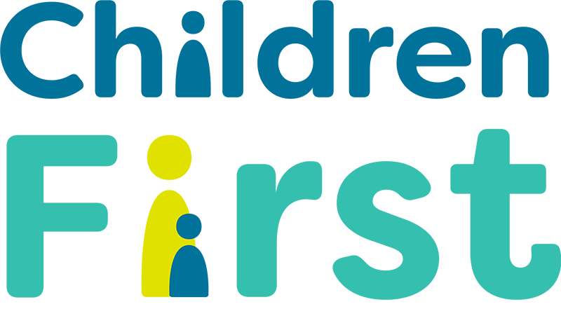

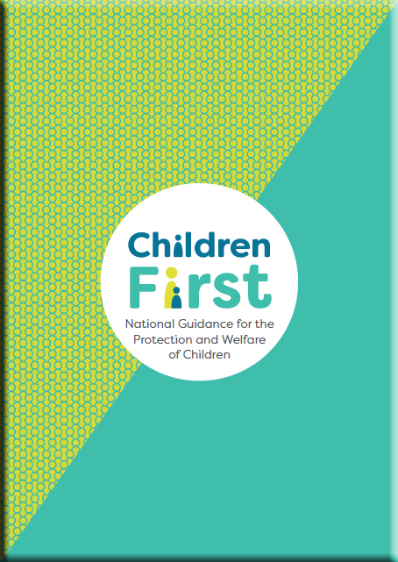 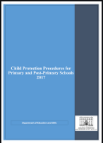

**Child Protection**



3

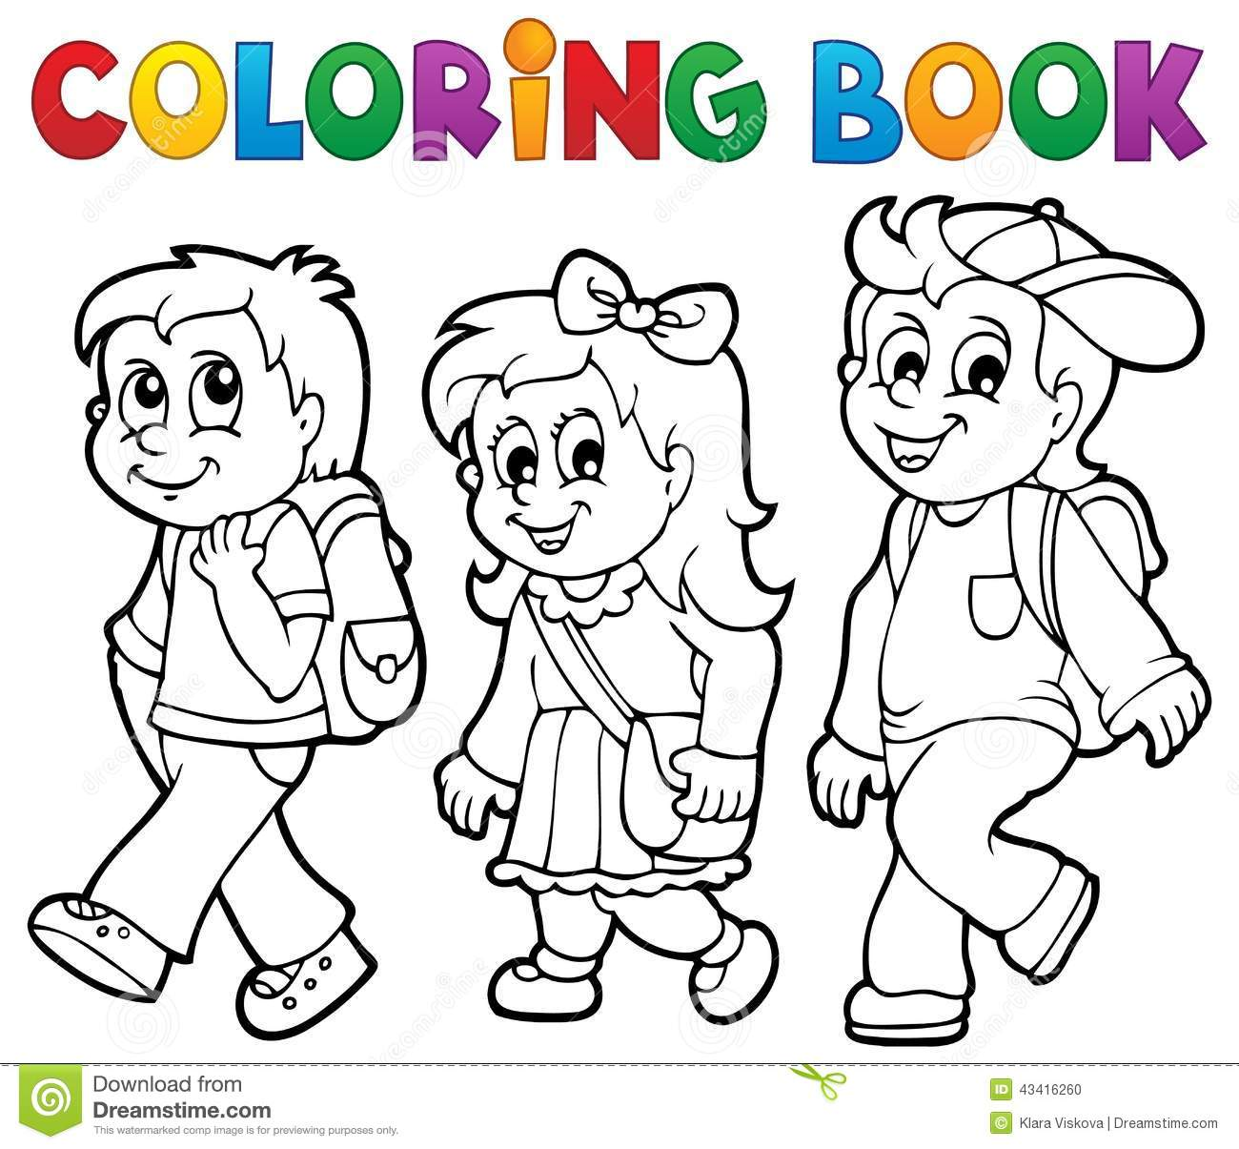

**Uniform**

The uniform consists of a navy crested tracksuit top over a yellow polo shirt. The crested tracksuit top is available from Mary and Marie’s shop in Edenderry. Alternatively, sew-on and/or iron-on crests are available from the school office. These can be sewn onto plain navy tracksuit tops. There is no requirement to have a crest on the polo shirt.

The children wear navy trousers or a navy skirt or pinafore.

The decision has been taken not to specify a particular colour of shoes, so as to allow for individuality and comfort. Please ensure that children wear suitable, comfortable footwear to allow for safe and free movement during playtime.

On P.E. days the children will be allowed to wear a navy tracksuit bottoms and runners with their school tracksuit top. The class teacher will let you know which days are P.E. days in early September.

Most of the uniform can be purchased at a reasonable cost in most supermarkets and department stores.

Minimal jewellery such as a watch or stud earrings are permitted. Other items such as bracelets and drop earrings can cause the child an injury or distress when broken or lost.

Please label all jackets, coats, jumpers and sweatshirts. We also advise that you clearly label your child’s lunchbox and pencil-case. It is very difficult to keep track of things if they are not clearly labelled.

Please ensure that children can recognise their own coats, lunch boxes etc., and can put on and take off their coats, open and close their bags and lunch boxes, can go to the toilet without assistance, flush the toilet after use, and wash and dry their hands.

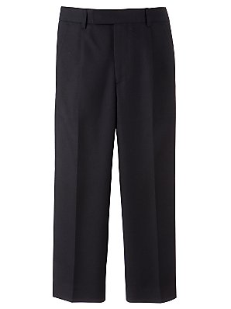  

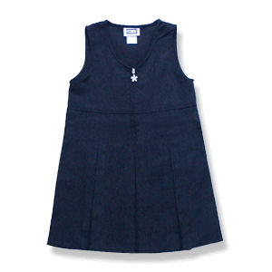  

4

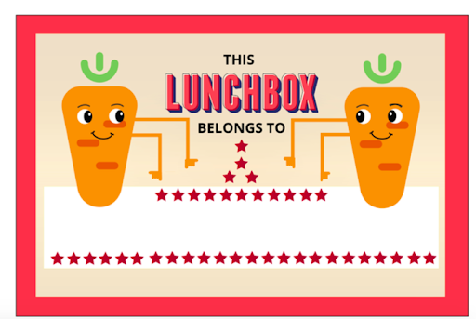



**Lunches**

Our school operates a healthy eating policy. Please read this policy on the policies page of our school website, [www.stconlethsns.weebly.com](http://www.stconlethsns.weebly.com) . Lunch will be eaten in the classroom before the children go out to play.

### We do not allow snacks known to be high in sugar, saturated fat, salt, additives and preservatives, including the following:

### Crisps (including crisp-style snacks)

* Fizzy drinks (including fizzy fruit-flavoured water, juices, etc)
* Sweets
* Chocolate biscuits/bars
* Nuts
* Chewing gum
* Fruit winders
* Popcorn.

*We respectfully ask that nuts are not packed in lunchboxes as many children have allergies to nuts.*

School lunches are provided for all children who wish to avail of them. Lunches are prepared daily and delivered fresh to school. The lunch consists of a roll/sandwich, and two pieces of fruit. Children are asked to bring their own water to school. . A fee of €10 per family per term will be charged to cover the administration costs of the lunch club. Lunch club forms are distributed and must be returned to school with the appropriate fee.

For those children not availing of the school lunch scheme, here are examples for healthy lunch ideas:

* Sandwiches/crackers/breadsticks/wraps/rice cakes.
* Fruit (which your child can easily manage) e.g. raisins, grapes, bananas, peeled oranges, apple slices.
* Salad, tomatoes, rice/pasta dishes.
* Vegetable sticks e.g. carrot sticks, celery.
* Water.
* Yoghurts – please ensure that your child has a spoon.

Please ensure that your child’s lunchbox is labelled. If children do not finish lunch it will remain in the lunch-box and be brought home. Children are asked to bring uneaten lunch and waste home in the lunch-box.

5

**Allergies, Administration of Medicine, Health Issues**

The Board of Management has a duty to safeguard the health and safety of pupils. However, prescribed medicines will only be administered after parents of the pupil concerned have written to the Board of Management requesting the Board to authorise a member of the school staff to do so. This does not imply a duty upon teachers personally to undertake the administration of medicines or drugs.

Under no circumstance will non-prescribed medicines be either stored or administered in the school. The Board will seek indemnity from parents in respect of any liability arising from the administration of medicines

The school generally advocates the self-administration (e.g. inhalers) of medicine under the supervision of a responsible adult, exercising the standard of care of a prudent parent. Parents are responsible for the provision of medication and notification of change of dosage.

Teachers have a professional duty to safeguard the health and safety of pupils, both when they are authorised to be on the school premises and when they are engaged in authorised school activities elsewhere.

The Board of Management requests parents to ensure that teachers be made aware in writing of any medical condition suffered by any child in their class. This does not imply a duty upon teachers personally to undertake the administration of medicines or drugs.

Where there are children with long-term health problems in school, proper and clearly understood arrangements for the administration of medicines must be made with the Board of Management. This is the responsibility of the parents/guardians. It would include measures such as self-administration, administration under parental supervision or administration by school staff. Where children are suffering from life threatening conditions, parents/guardians must clearly outline, in writing, what should be done in a particular emergency situation, with particular reference to what may be a risk to the child. If emergency medication is necessary, arrangements must be made with the Board of Management. A letter of indemnity must be signed by the parents in respect of any liability that may arise regarding the administration of medication. Further information and relevant forms for parents are available in our Administration of Medicines Policy which is on the school website [www.stconlethsns.weebly.com](http://www.stconlethsns.weebly.com). If there is an accident at school, your child will receive first aid for minor cuts and bruises. If there is anything more serious, you will be contacted by school. It is vital that the school has your current contact details and that any emergency contact numbers are submitted to the school secretary at [secretary@stconlethsns.ie](mailto:secretary@stconlethsns.ie) or by ringing 046 9553490.

Head lice are unfortunately quite common in primary school settings. Where possible, please tie your child’s hair back. We advise that you check your child’s hair weekly. If infected, please inform the school and treat your child. If there is an outbreak of notifiable infections, the school will notify parents and give appropriate advice.

In the interest of minimising infections and contamination, please ensure that your child is able to use the bathroom and wash his/her hands properly. Hand hygiene, respiratory etiquette and desk/workspace cleaning will be a normal part of the school routine and we would be very grateful if you could start these practices with your child before school opens in September.



.

6





**Communication/Contact Details**

As previously stated, it is vital that the school has up to date contact details for you. If you change your address, phone number or e-mail address, please notify the school immediately. The school retains the contact details of all visitors to the school, including parents that visit to drop things into the office and parents that collect children early. As part of our Safeguarding Children Procedures, all visitors are kindly requested to report to the school office, before proceeding into the school building or play areas.

If you need to collect a child, please visit the secretary at the school office. The secretary will phone the classroom and arrange for the child to come to the office while you sign the child out. We also request that if a child is arriving late to school, or returning to school after an appointment that you sign the child in. If you need to drop something to your child during the school day, please proceed to the secretary’s office.

Our Communication Procedures are published in detail on the Policies page of the school website [www.stconlethsns.weebly.com](http://www.stconlethsns.weebly.com). It is vital to remember that in all cases the class teacher is the first port of call for any concerns about your child. The class teacher works closely with special needs teachers and special needs assistants and can convey any concerns that you have to the relevant and appropriate members of staff. A complaints Procedure was agreed between Primary School Management Bodies and Teachers Unions in 1993. This procedure is also published on the policies page of the school website.

It is school policy that children are not allowed to have mobile phones in school. Any phones that are found with pupils are confiscated and can be collected from the school office by the parents. Pupils are not allowed to bring mobile phones or devices on school trips etc. unless an arrangement has been made to do so. In this instance, written notification will issue to parents/guardians.

A school newsletter is issued regularly. This will keep you informed of news and events in our school. We also have our school website [www.stconlethsns.weebly.com](http://www.stconlethsns.weebly.com) , where you will find lots of information about our school. Class teachers communicate using Google Classroom and Seesaw. These platforms allow the children to engage online and develop important digital skills.

*Birthday Invitations: Please note that teachers do not take responsibility for distributing invitations to birthday parties. Invitations should not be distributed in the classroom as this can cause exclusion, conflict and hurt.*

7

**Parental Involvement**

Parent Teacher Meetings: Formal Parent Teacher Meetings are held in November each year. This has allowed the child to settle into class for the first half term. Junior Infant teachers meet with parents early in the first term to explain homework and to give guidance and explain expectations. If you have concerns in relation to your child and the school, please make an appointment to speak to the class teacher directly. Arrangements can be made to speak at an appropriate time, that will suit both parties and that does not interfere with classroom teaching. Please remember that the class teacher is your front-line contact and will always be your first port of call. He /she will liaise with the relevant staff as necessary. (E.g. SEN teachers, the Principal, external therapists, consultants etc.)

Parental Involvement: We believe that parents/guardians, the school and the community working together enhance the education and lives of our pupils. Parental involvement in St. Conleth’s National School is encouraged, welcomed and appreciated. If you have a particular skillset or talent that you feel would benefit the school, please let the class teacher know. In recent years parents have been involved in story-time sessions and in Engineering workshops.

We have an active Parents Association in the school. The members of the committee organise fundraising activities and events for the children. We welcome parental involvement in policy formation, fundraising and general events in the school. Please sign up for the Parents Association. It is a wonderful way to support your child’s school.

The school has established its Board of Management. This Board holds office for a four-year term. There are two parent nominees on the Board of Management and the positions are open to all parents of children in the school. Parents are notified of the elections every four years and the procedures for nominating and electing are communicated to all parents.



**Get involved! Make a difference!**

8

**Curriculum, Assessment**

The Department of Education and Skills is responsible for the education of children in Ireland. Under the curriculum laid down by the Department all children are taught Language (English and Irish), Maths, Social, Environmental & Scientific Education (History, Geography & Science), Physical Education, Drama, Music, Visual Arts and Social, Personal and Health Education. As a Catholic School, we also teach the Grow in Love Religion programme throughout the school.

Our heritage is important to us at St. Conleth’s National School, and the Irish language and culture plays an important part in the everyday life of the school. Staff and children speak Irish informally throughout the school day. We encourage you to use any Irish phrases or ‘cúpla focal’ that you have at home.

The Primary School Curriculum is constantly being reviewed and updated. The curriculum is available to view on the National Council for Curriculum and Assessment website - [www.ncca.ie](http://www.ncca.ie).

All primary schools are required by the Department of Education and Skills to administer standardised tests. Standardised tests in English and Maths measure your child’s achievement compared to other children in all schools at the same class or age level. We also administer diagnostic testing from time to time to assess the individual needs of children and how best to address emerging needs.

**School Books, Copies & Other Costs**

As of September 2023, all school books and copies are free. Parents will not be charged any rental fee or deposit. We ask that parents encourage children to take care of the books that are on loan to them as books are costly. There will be times during the school year when you will be asked for money, for example specialist tutors/classes or money to pay for tours or trips. We understand that some parents may experience may have difficulty with bills, particularly if there are several children from one household. If this is the case, please ring the school office at 046 9553490. Arrangements and accommodations can be made and these will remain confidential. Our priority is to ensure that no child misses out on school activities.

As the children progress though the school, you will be asked to pay for activities and events. The Aladdi system allows for money collections. Please make sure that you can access the Aladdin Connect system. If you encounter any difficuties with the app, please contact the school office so that we can rectify the situation.

A personal insurance policy is available as an option through Allianz Insurance. The cost varies from year to year. (Details on the school website [www.stconlethsns.weebly.com](http://www.stconlethsns.weebly.com). )

9

**Our Mission Statement**

Our Mission Statement is available to read on our school website, [www.stconlethsns.weebly.com](http://www.stconlethsns.weebly.com). The statement opens with our school motto, ”Ar Aghaidh le Chéile” or “Forward Together.” This motto reflects the reality of the whole school community working together. Pupils, Staff, Board of Management, Parents, Parish and the wider community together help make St. Conleth’s National School, Derrinturn, a better place for learning and teaching.

The statement outlines our ethos as a Catholic School, operating under the patronage of the Bishop of Kildare and Leighlin. Christian values such as those shown in the illustration below are an integral part of life at our school.

**Christian Values at St. Conleth’s National School** Our Mission Statement outlines the roles of parents, staff and management at St. Conleth’s National School. The importance of inclusivity and equality are evident in the Mission Statement. St. Conleth’s National School celebrates the uniqueness of each child in our school, as it is expressed in each pupil’s personality, intelligence and potential for development. Our school strives to nurture each child in all dimensions of his or her life – spiritual, moral, cognitive, emotional, imaginative, aesthetic, social and physical. By celebrating children being children, and enriching the child’s life we see foundations being laid for happiness and fulfilment in later education and in adult life. In our school, we create an atmosphere of understanding, care, worth and mutual respect to prepare the child for lifelong learning and to enable the child to contribute to the good of society.

Sense of Wonder Authenticity Concern Learning

10

**Getting Ready for School**

Here are some tips that offer practical help for you and your child as you get ready for “BIG SCHOOL”.

* Talk about school. Let your child know that school is a happy place and there will be a big welcome for all the children.
* Remind your child that at school we will make lots of new friends.
* Talk about the exciting things that we will do at school, like playing, painting, learning new things…..
* Give your child an input into school life like choosing a schoolbag, lunchbox new shoes etc.
* Practise nursery rhymes and read well known fairy tales. Familiarity reassures children and improves confidence. Reading together fosters reading readiness, the key to introduce your child to the mechanics of reading, text direction and the conventions of writing. More importantly you would be nurturing a motivation to read and a love for books.
* Play helps a child develop motor skills, oral language skills and vocabulary. Play also encourages social skills which help to foster friendships. Games have incredible educational and developmental value.
* Help your child to become more independent in the months leading up to September. It will help greatly if your child can
* Button and unbutton a coat and hang it up.
* Wear Velcro shoes. Laces are tricky!
* Practise opening and closing lunchboxes, drinks & schoolbags.
* Use the toilet without help and manage trouser buttons. (Elastic waist is best!)
* Practise personal hygiene and cleanliness. Your child should know how to flush the toilet and wash hands without help or instruction.
* Use a tissue & to sneeze or cough into the elbow.
* Share toys and games with others and take turns.
* Tidy up and put things away.

Separation is ok! Arrange for your child to spend a little time with someone other than yourself. This is particularly important if your child has not been to pre-school. When children have the experience of being away from you for a short time, it reduces anxiety levels for both parent and child.

Make sure that your child has plenty of sleep. Starting school will be exciting and very tiring!

 

11

**The Early Days**

For the first couple of days, parents are welcome to bring the children into the classroom to help them to settle down. Reassure your child that you will be back soon to collect them. It is not a good idea to hang around for too long, as this can upset the children. Remember, it is a valuable part of your parenting skills that you encourage your child to be independent enough to go to school. If there are any concerns, the school will contact you. Rest assured that the children are usually fine within minutes of the parent’s departure. If you are relaxed, your child will be more relaxed. Grandparents and other relatives are not allowed into the classroom, unless they are substituting for parents. Too many adults in the classroom can be frightening and intimidating for young children. 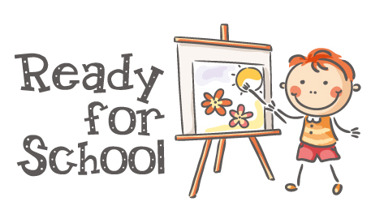

We want the children to have the best possible experience when they start school at St. Conleth’s National School. We encourage all parents to talk to the class teacher. If there is any other information that you need, please ring the school office and we will do everything that we can to help your child to settle into school. We want everybody to have a positive and happy start to school life. If your child has any additional learning needs or is engaged with services such as Enable Ireland or the HSE, it is vital that you let us know, so that we can support each individual child as best we can.

Talk to your children about school. Always start your school conversation on a positive note, e. g. *“Who did you have fun with today?” “What did you enjoy in school today?”* If you ask your child if people were crying or fighting that will not only be the focus of the chat, but might indeed be something they start looking for. They might miss out on happier times at school. Encourage your child to mix with others rather than depending on just one friend. What happens if that one friend is out sick? The children are naturally social and enjoy mixing.

Be sure to collect your child on time. Children become very upset if they think they have been forgotten. If you cannot collect your child please let the child know who will be collecting them. For the first two weeks, your children will finish early. The transitional phase is very tiring and it takes these two weeks to settle into school routine.

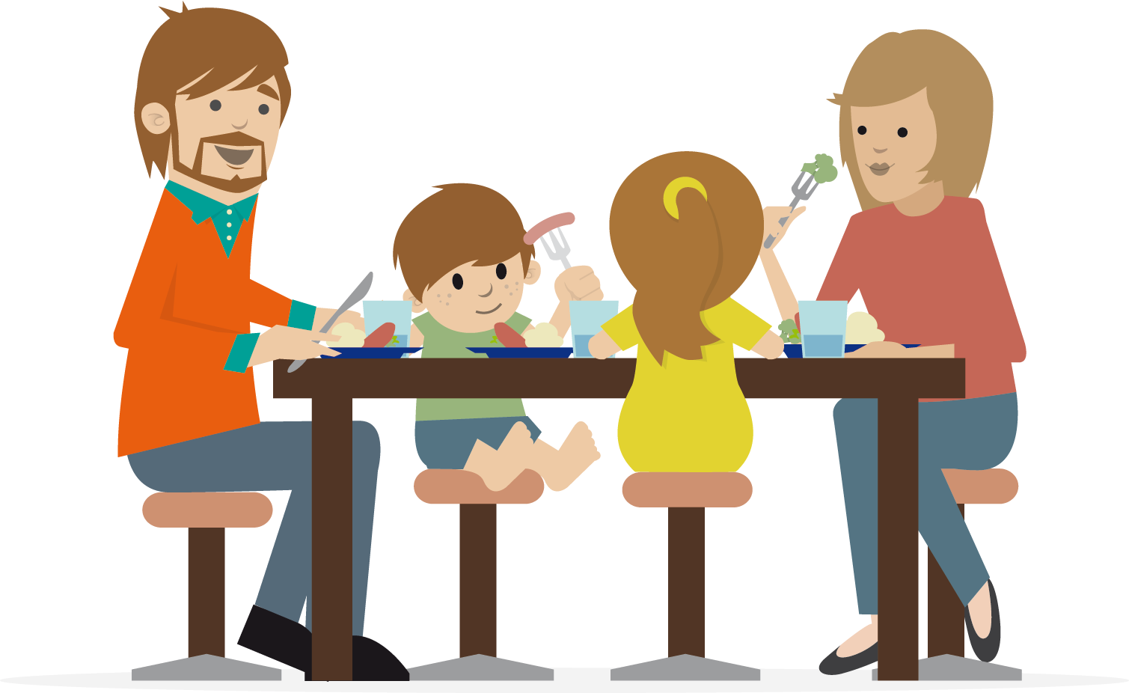

12



1. Be Prepared
   * Do your homework.
   * Wear your uniform or school tracksuit.
   * Bring a healthy lunch or eat the school lunch.
   * Bring your books, copies and equipment to school.
2. Be Courteous

* Ask permission.
* Say ‘please’, ‘thank you’ and ‘excuse me’.
* Wait your turn in class, in corridors, in the office and at play.

1. Be Respectful

* Respect your property and that of others.
* Respect school property.
* Respect the feelings of others.
* Respect differences.
* Respect the environment.

1. Be Safe

* Play safely, walk safely and sit properly in class.
* Do not cycle, scoot or skate on the school grounds.
* At playtime, do not go outside of your play area or to the front of the school or the car park.
* Obey the traffic warden and adults at school.

1. Try Your Best

* Always work hard in school, doing your best at all times.

🙤🙦

13



14

*Thank you for taking the time to read this information booklet and we hope that you have found it useful. We look forward to welcoming all the children and we hope they enjoy their time with us here at St. Conleth’s National School. Should you need to know more please make contact or visit the school website.*



Website: [www.stconlethsns.weebly.com](http://www.stconlethsns.weebly.com)

Phone: 046 9553490

E-mail: [secretary@stconlethsns.ie](mailto:secretary@stconlethsns.ie)

